## Abstract

This project involved development of a system which allowed for gathering, and subsequent viewing and analysis, of end-of-class feedback from students using a tablet-based mechanism. An android app was therefore developed which provided a quick, easy and intuitive method of providing feedback. Additionally, a website was developed which allowed staff to view the feedback for their classes (and, depending on their level of access, view feedback for others’ classes and perform C.R.U.D operations on the database). Testing results were on the whole very positive, with students finding the app easy and enjoyable to use.

# Introduction

This project is a continuation of earlier rateMyLab work by the School of Computing: it further develops an app for Android tablets to be placed in student labs/lecture theatres to gather from students: (1) end-of-class ratings; (2) text comments; (3) (possibly) attendance information.

The project also provides a system which will allow for analysis of the feedback data (e.g. for particular lecturers, modules, etc.), which will be stored in a server-side database. The system will be accessible to all lecturers for their relevant classes and modules, and admin staff who will have edit privileges.

Throughout this project, the end user is to be the focal point. The user will be consulted with throughout development, and the app will be tested in the end user environment (i.e. in a lab/lecture) in order to ensure that feedback is as relevant as possible.

# Background

Student feedback is an important tool that benefits all contributors to a lecture or lab class: (i) giving students a mechanism to report their assessment of the class in question and thereby influence related classes and (ii) helping lecturers to identify and tackle issues experienced by their students and thereby subsequently develop the curriculum accordingly (Johnson, 2009).

There is an already existing app (RateMyLab), developed by the School of Computing, which aimed to provide a mechanism for obtaining such feedback. It provided students with a simple, single-screen interface which contained three ‘smilies’, or faces – one sad face, one neutral and one happy (*see Figure 1, below*). By touching the sad face, a student would indicate that they felt the class was of poor quality – and likewise the neutral and happy faces indicated average and good quality classes, respectively.

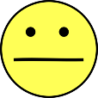

Figure 1: Rough sketch of the interface of the original 'RateMyLab' app

It was felt by staff at the School of Computing that this app needed improvement – although it was simple and quick to use, the feedback it obtained was seriously lacking in detail (since although it allowed users to specify whether a lab was good, bad or average, this was without specifying *why*). This problem is what is aimed to be solved with this new phase of development. The aim is to provide a mechanism which allows for richer feedback, whilst maintaining the simplicity and accessibility of the original rateMyLab app.

### Previous Work

On a more global scale, there has been similar work done in the form of Classroom Communication Systems (CCS). These systems have evolved, from being based on multiple-choice remote controls and then PDAs, to the more modern medium of Tablet PCs with wireless connectivity, the idea being that every student in a lab/lecture has one of these devices, and they are all connected through the medium of the CCS. These systems are very useful for bringing classes together in a collaborative effort, giving the mechanism for feedback and allowing for live in-class polling, and demonstration of both good and bad examples and scenarios (*see Figure 2, below, for a diagram of the CCS learning cycle*). Group work is also made much easier as students do not have to physically move around to work together. (Theys et al, 2005)

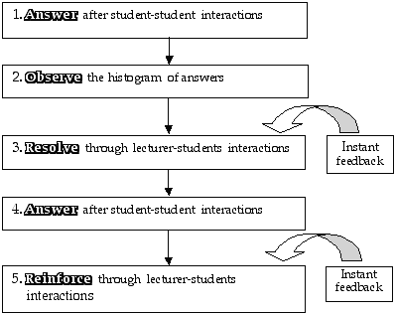

Figure 2: CCS learning cycle (Sharma et al, 2005)

The main difference between RateMyClass and the traditional CCS is that, while CCS’s are more geared towards live feedback and dynamic lecture content (with increased student engagement the priority) (Dufresne et al, 1996, p. 2), RateMyClass is a more static, narrowly-focused mechanism, with feedback being given only after the conclusion of classes; the main rationale being that lecturers can gain valuable insight which allows them to make improvements to these classes. The RateMyClass app is primarily for the benefit of lecturers, unlike the CCS.

Another similar piece of work involves the use of augmented reality (AR) systems (e.g. Google Glass) to provide lecturers with live feedback from students in a seamless fashion, through the use of various visualisations (*see Figure 3, below*).

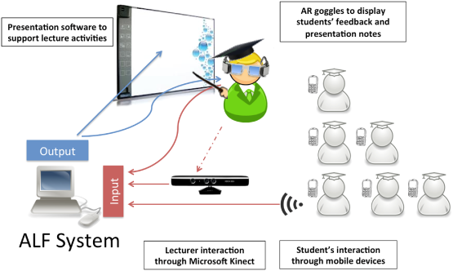

Figure 3: Architecture of the proposed ALF system (Zarraonandia et al, 2013)

The proposed benefits of such a system would include the fact that such a system would avoid breaking the ‘flow’ of lectures, which often occurs when lecturers have to directly communicate with and ask questions of students, and that it encourages more students to give feedback by keeping their anonymity, removing the need for them to speak up in class (Zarraonandia, Aedo, Díaz, & Montero, 2013).

Additionally, there has been development of a smart phone app (see *Figure 4, below*) which allows student to check in to class and leave feedback (Foth et al, 2012).

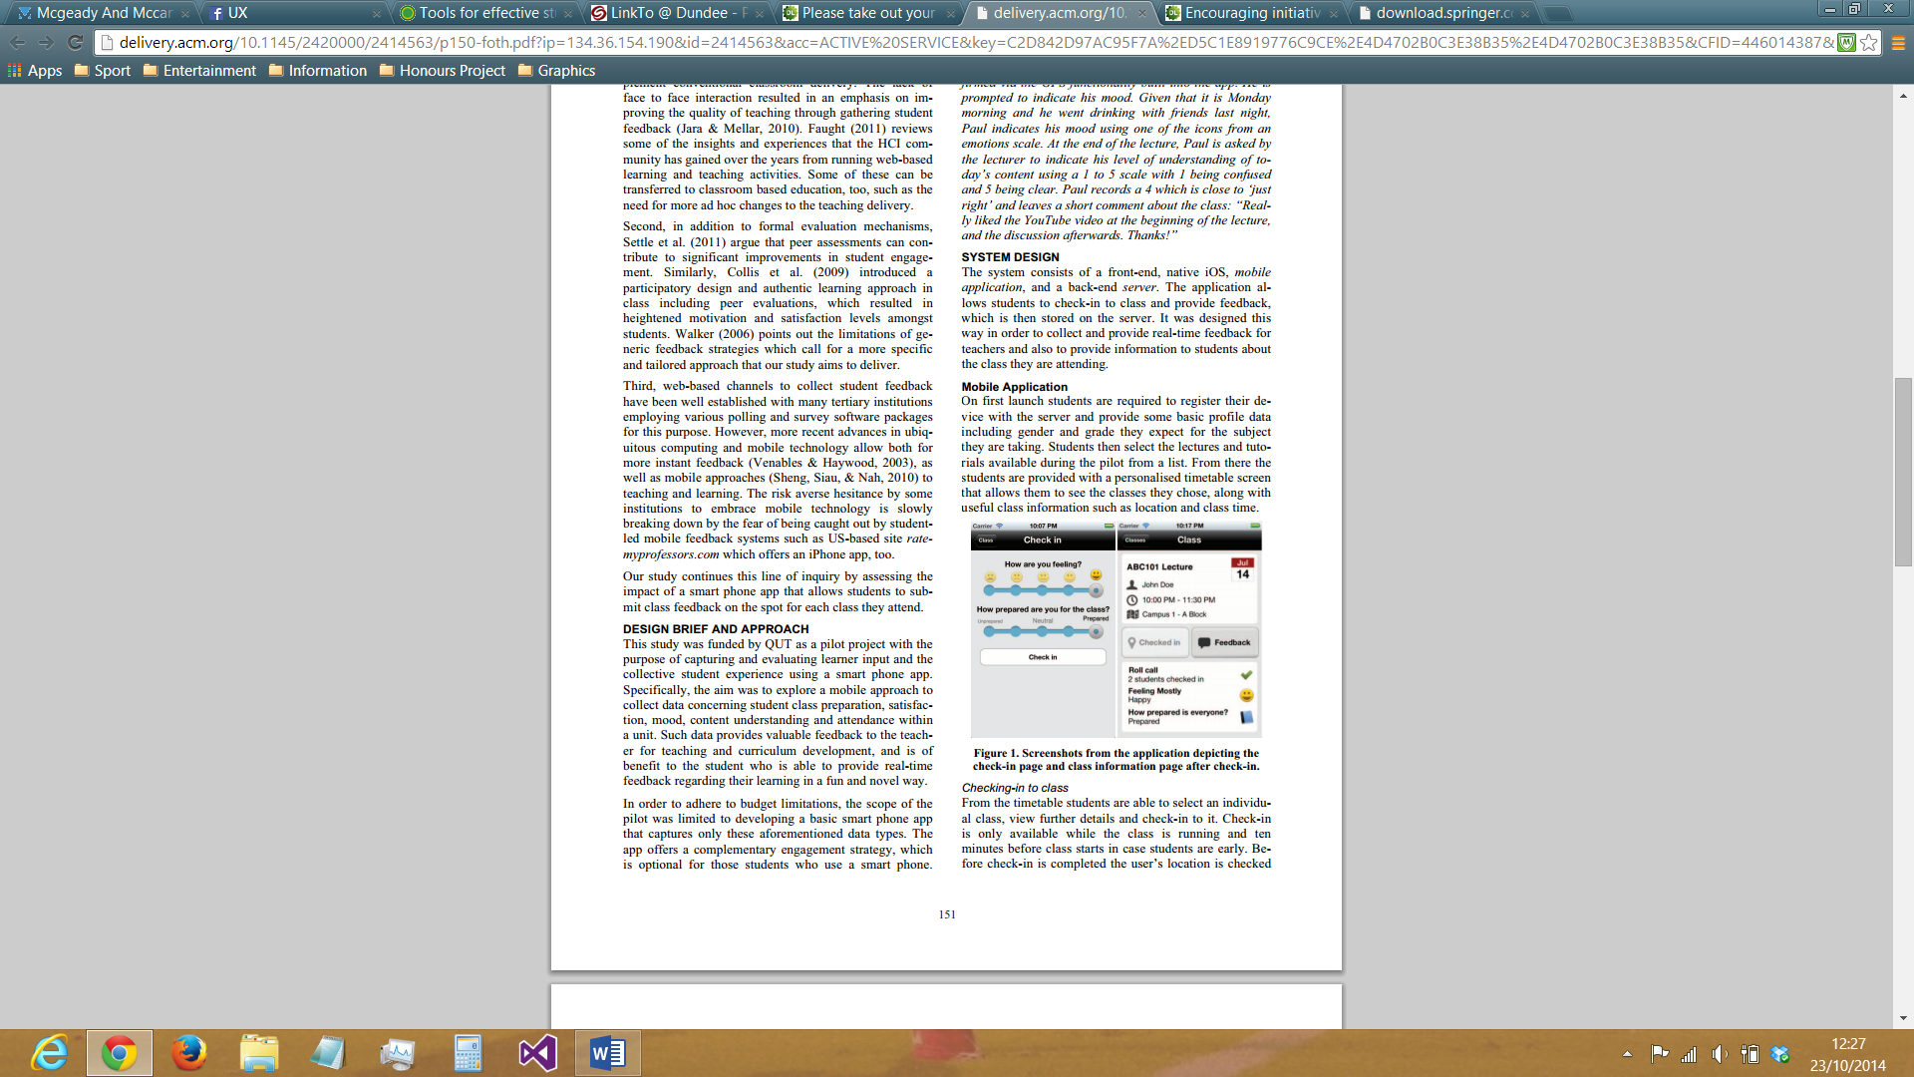

Figure 4: Screenshots from the app (Foth et al, 2012)

This app provides the following functionality:

* Checking-in to class
  + Students are able to select a class from a list of classes and ‘check-in’ to it. This can only be done during the class (and 10 minutes before it starts). GPS is used to check that students are actually physically present at the class. Students can provide initial feedback as to ‘how they are feeling’ (ranging from bad to very unhappy (smiley) to very happy (smiley)) and ‘how prepared they are for class’ (ranging from ‘Unprepared’ to ‘Prepared’)
* Revealing feedback from other students
  + As soon as students ‘check-in’, they can view certain collective items of information about the other students who have also done so. For example, the total number of students who are checked in, and the average levels of happiness and preparedness of the class.
* Providing class feedback
  + Final class feedback can be given by student in the form of two 5-point Likert scales, one rating the class in general and the other rating how well they understood the information given in the class. Students are sent reminders 10 minutes before the class ends in order to make sure none of them forgets to give feedback

As regards tablet-based systems which more closely mirror the functionality, architecture and rationale of RateMyClass, there are no doubt many real-world examples, but, in terms of documented commercial solutions, it appears there are no systems which are really comparable.*

*Searches were made across Google Scholar, Dundee University Library and ACM Digital Library

# Specification

The following user stories were identified and developed after initial user interactions and discussions (*see Appendix A for full detail*):

As a student I want to…

* Be able to give feedback on how interesting the lab/lecture was (and why) so that lecturers can use this knowledge to make their classes more interesting
* Be able to give feedback on how innovative the lab/lecture was (and why) so that lecturers can use this knowledge to make their classes more innovative
* Be able to give feedback on how informative the lab/lecture was (and why) so that lecturers can use this knowledge to make their classes more informative
* Be able to give feedback on how interactive the lab/lecture was (and why) so that lecturers can use this knowledge to make their classes more interactive
* Be able to give feedback on how intelligible the lab/lecture was (and why) so that lecturers can use this knowledge to make their classes more intelligible

As a lecturer/member of staff I want to…

* Give students the option to select why a particular area/factor was bad or good (from a list of predefined statements) so that I can get more rich feedback, while students will not have to spend time writing out comments in their own words, and they cannot make irrelevant/inappropriate comments
* Be able to analyse the data after class so that I can make sense of the data and see the bigger picture, along with any trends, and adjust classes accordingly
* Be able to view the feedback(s) for individual classes so that I can determine their quality
* Receive a summary of feedback for each class that I conduct by email so that I can ascertain how well I have done
* Select which module and lecturer the class belongs to immediately upon starting the app so that The data can be referred to later in the correct context

As a Dean I want to…

* To be able to view the feedback for all labs/lectures handled by a particular lecturer so that I can determine if individual lecturers are doing a good job or not
* Be able to view the feedback for all classes taken by a particular year group so that I can determine how well a particular year group is doing

The three aforementioned user groups were decided upon by a simple process of deduction. Here follows this thought process: the app will be used by students, therefore stories can be elicited from them; lecturers will obtain info via the app and view this info in the website, therefore will have stories concerning both; some lecturers will have special privileges due to their status as a Dean, therefore it is likely that there will be stories unique to them.

# Design, Implementation, Testing & Evaluation

### Overall System Design

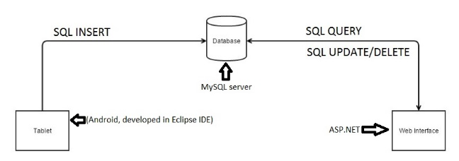

Figure 5: Early design concept of the architecture of the RateMyClass system

Before development of the web interface began, a decision had to made as regards which technology would be used to implement it. After much research, the dilemma became whether to develop the web interface using ASP.NET (which had been used in development of previous projects) or a more challenging, unfamiliar language in Ruby on Rails. On the one hand, ASP.NET would be much easier to implement, with there being much experience of using this previously (unlike Ruby on Rails); but, once the steep learning curve had been overcome, by all accounts Ruby on Rails would actually allow for quicker and more automated generation of a web interface to the database. That being said, with the limited time within which the project had to be completed (also bearing in mind the steep learning curve required for programming in Ruby on Rails), it was decided that ASP.NET would be used in order to achieve the highest quality results possible.

Initially, the Eclipse IDE was to be used for the development of the app itself, but it was later decided that Android’s own ‘Android Studio’ software would be used due to its relative simplicity and robustness. One issue that arose was that there is no available connector for use between Android apps and MySQL databases. The only real way to solve this was to link the two via a web interface, and therefore PHP files were used as intermediates between the app and the database. For example, the app would obtain data from the database by making a GET request to a certain PHP file which would in turn send a SELECT statement to the database and encode the results in a JSON response. Likewise, to insert data, the app would send a request to a PHP file, with the data to be inserted attached as parameter(s), which would then insert the data using an INSERT statement and return a response indicating the success of the insertion (e.g. a Boolean ‘true’/’false’ value). In this way, the problem of connecting the app to the database would be solved.

Both the app and the web interface/site would link to the main hub of the system, namely a MySQL database running on a central server. This database would hold all the feedback and class data which would be inserted into it by the app and made viewable on the website, along with module, staff, and teaching assignment data which would be accessible in the app and editable on the website.

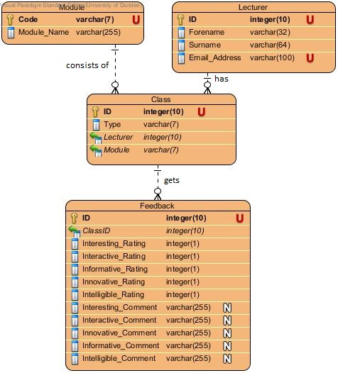

Figure 6: Entity-Relationship Model of the RateMyClass database in its initial state

Initially, the database would contain only 4 tables (*see Figure 6, above*), although later a fifth was added in order to store teaching assignments (*see Figure 7, below*).

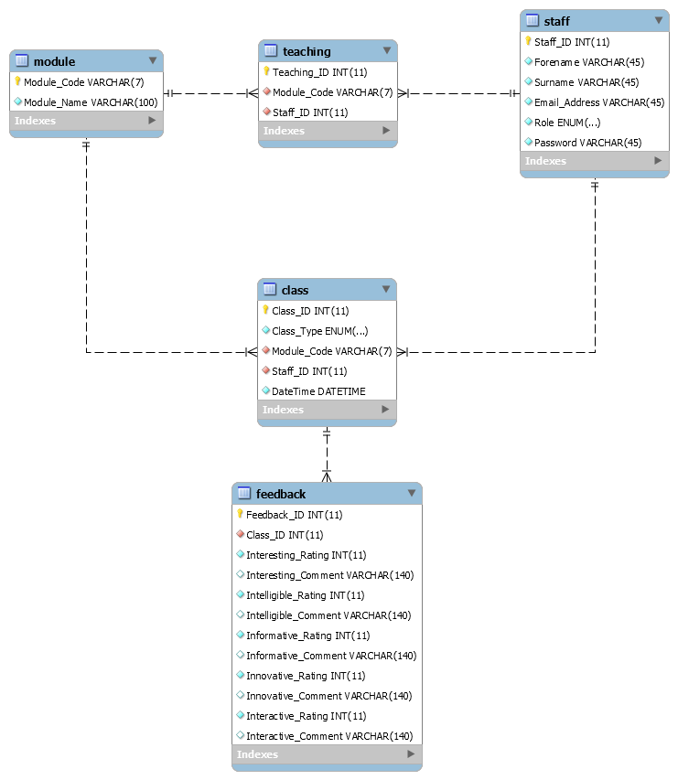

Figure 7: Entity-Relationship Model of the RateMyClass database in its finalised state

This table was needed as end users indicated that during creation of a new class in the app (*see Figure 11*), they did not want the app to allow users to select any member of staff in tandem with any module – therefore a table needed to be created in order to link modules to certain members of staff (allowing implementation of the feature that only assigned members of staff can be selected with a particular module).

Here follows some example SQL code used to implement part of the database schema (the ‘class’ and ‘feedback’ tables):

*CREATE TABLE `class` (*

*`Class_ID` int(11) NOT NULL AUTO_INCREMENT,*

*`Class_Type` enum('lab','lecture') NOT NULL,*

*`Module_Code` varchar(7) NOT NULL,*

*`Staff_ID` int(11) NOT NULL,*

*`DateTime` datetime NOT NULL,*

*PRIMARY KEY (`Class_ID`),*

*UNIQUE KEY `Class_ID_UNIQUE` (`Class_ID`),*

*KEY `fk_module_idx` (`Module_Code`),*

*KEY `fk_staff_idx` (`Staff_ID`),*

*CONSTRAINT `fk_module` FOREIGN KEY (`Module_Code`) REFERENCES `module` (`Module_Code`) ON DELETE NO ACTION ON UPDATE CASCADE,*

*CONSTRAINT `fk_staff` FOREIGN KEY (`Staff_ID`) REFERENCES `staff` (`Staff_ID`) ON DELETE NO ACTION ON UPDATE CASCADE*

*) ENGINE=InnoDB AUTO_INCREMENT=79 DEFAULT CHARSET=utf8;*

*CREATE TABLE `feedback` (*

*`Feedback_ID` int(11) NOT NULL AUTO_INCREMENT,*

*`Class_ID` int(11) NOT NULL,*

*`Interesting_Rating` int(11) NOT NULL,*

*`Interesting_Comment` varchar(140) DEFAULT NULL,*

*`Intelligible_Rating` int(11) NOT NULL,*

*`Intelligible_Comment` varchar(140) DEFAULT NULL,*

*`Informative_Rating` int(11) NOT NULL,*

*`Informative_Comment` varchar(140) DEFAULT NULL,*

*`Innovative_Rating` int(11) NOT NULL,*

*`Innovative_Comment` varchar(140) DEFAULT NULL,*

*`Interactive_Rating` int(11) NOT NULL,*

*`Interactive_Comment` varchar(140) DEFAULT NULL,*

*PRIMARY KEY (`Feedback_ID`),*

*UNIQUE KEY `Feedback_ID_UNIQUE` (`Feedback_ID`),*

*KEY `fk_class_idx` (`Class_ID`),*

*CONSTRAINT `fk_class` FOREIGN KEY (`Class_ID`) REFERENCES `class` (`Class_ID`) ON DELETE NO ACTION ON UPDATE CASCADE*

*) ENGINE=InnoDB AUTO_INCREMENT=89 DEFAULT CHARSET=utf8;*

# Sprint 1

### Design/Implementation

#### User Story 1.1: I want to be able to give feedback on how interesting the class was (and why)

Developing this user story involved the creation of an input method whereby the user could give a percentage rating for how ‘Interesting’ a class was. This was implemented through the use of a native Android widget, the ‘Seek Bar’ (*see example code, below)*.

**Creation of seekbar in layout xml file:**

*<SeekBar*

*android:layout_height="wrap_content"*

*android:layout_marginTop="10dp"*

*android:layout_marginLeft="10dp"*

*android:id="@+id/seekBar"*

*android:layout_weight="1"*

*android:indeterminate="false"*

*android:layout_width="wrap_content" />*

**Initialisation of seekbar in activity:**

*final SeekBar mSeekBar = (SeekBar) findViewById(R.id.seekBar);*

*mSeekBar.getThumb().setColorFilter(Color.BLACK, PorterDuff.Mode.MULTIPLY);*

*mSeekBar.setOnSeekBarChangeListener(new SeekBar.OnSeekBarChangeListener() {*

*@Override*

*public void onProgressChanged(SeekBar seekBar, int progress, boolean fromUser) {*

*if (progress <= 33){seekBar.setProgressDrawable(getResources().getDrawable(R.drawable.seeker));}*

*else if (progress <= 66){seekBar.setProgressDrawable(getResources().getDrawable(R.drawable.seekeramber));}*

*else {seekBar.setProgressDrawable(getResources().getDrawable(R.drawable.seekergreen));}*

*}*

*@Override*

*public void onStartTrackingTouch(SeekBar seekBar) {*

*}*

*@Override*

*public void onStopTrackingTouch(SeekBar seekBar) {*

*}*

*});*

*mSeekBar.setProgressDrawable(getResources().getDrawable(R.drawable.seeker));*

This feature allowed users to provide an integer value in the range of 1-100 (i.e. a percentage), through an input method which outwardly seems entirely analogue. During consultation with various potential end users, this input method was recommended by a majority due to its simplicity and intuitive design – in other words, it was felt that this input method would not present any real learning curve for those using the app for the first time.

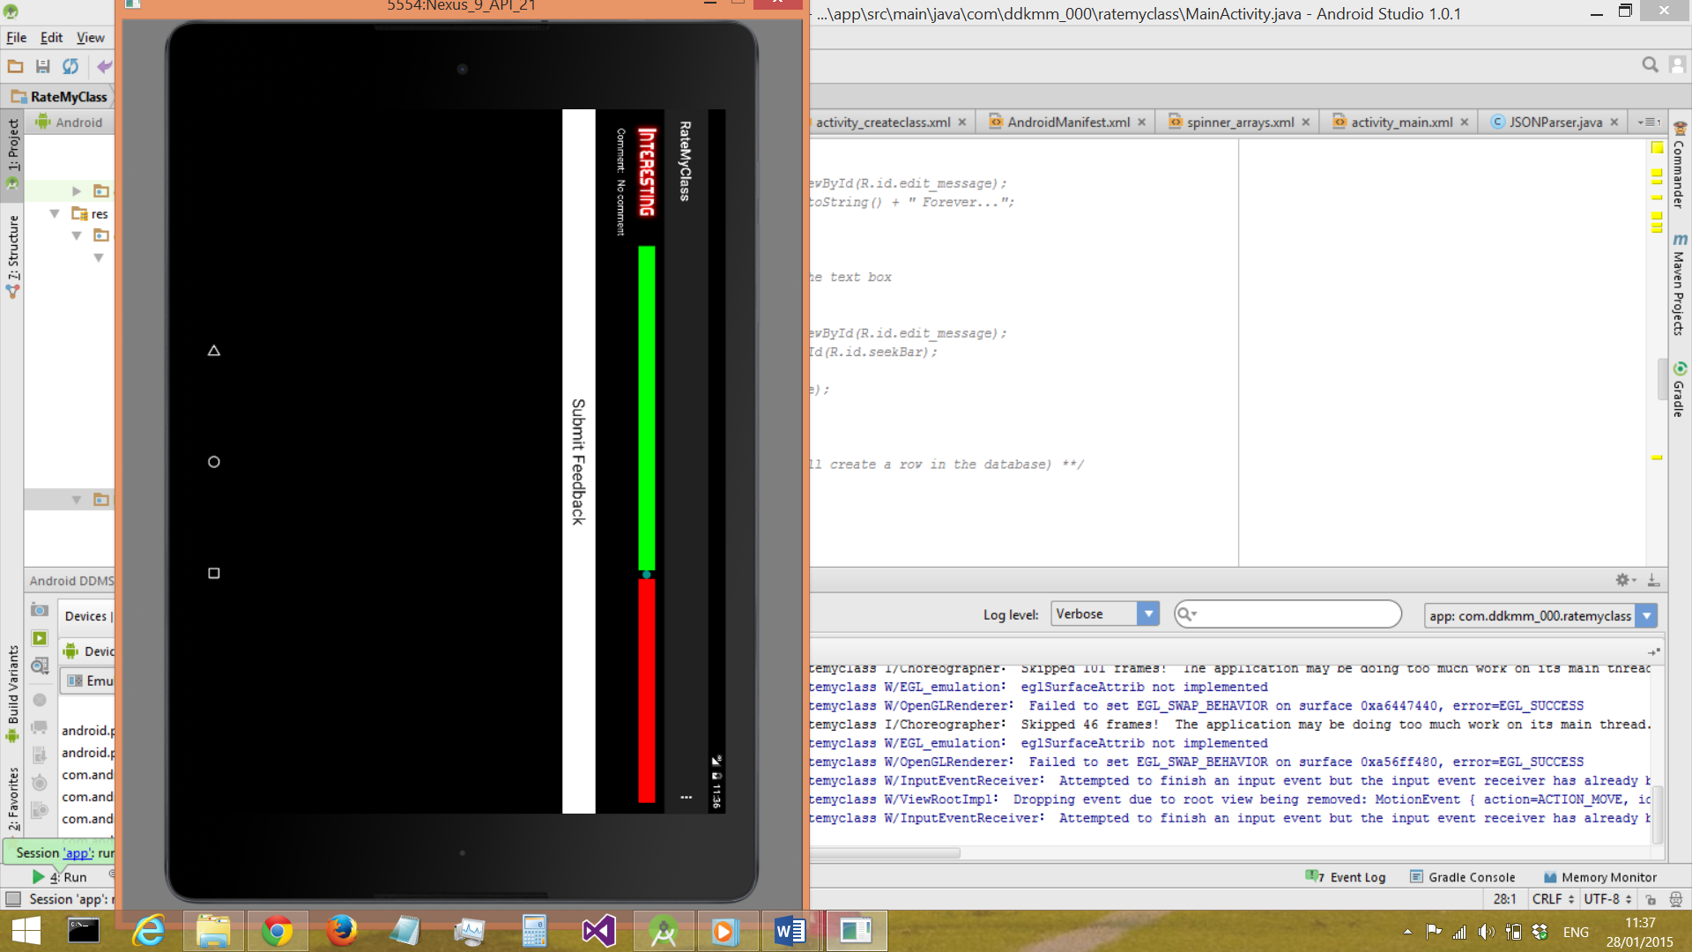

Figure 8: the Seek-Bar input method for giving a feedback 'score'

In the GUI, this value was not displayed to the user in order to preserve the seemingly analogue nature of the input, giving a more ‘natural’ feel to the interaction. The seek bar, at this stage in development, utilised a green-red split colour scheme (see *Figure 8, above*) which made the hidden value more clear to the user though, by making the green half of the bar increase in size as the selected value was increased.

#### User Story 2.1: I want to give students the option to select why a particular area/factor was bad or good (from a list of predefined statements)

Developing this user story involved the creation of an input method whereby the user could select one comment from a predefined list. This was implemented through the use of a native Android widget, the ‘Spinner’.

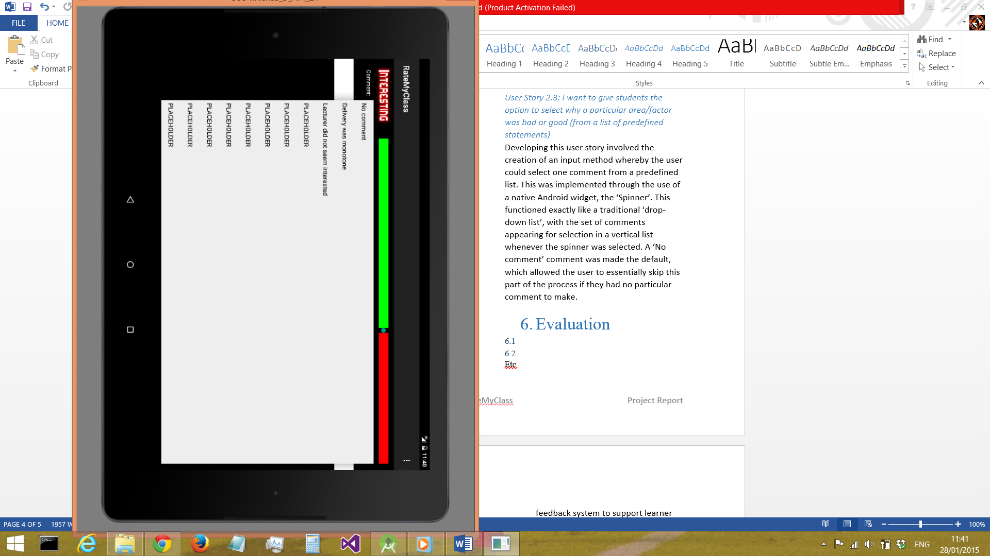

Figure 9: the 'Spinner' input method for comments

This functioned exactly like a traditional ‘drop-down list’ (see *Figure 9, above*), with the set of comments appearing for selection in a vertical list whenever the spinner was selected. A ‘No comment’ comment was made the default, which allowed the user to essentially skip this part of the process if they had no particular comment to make, thus facilitating the quickest usage of the app as possible.

### Testing

During this first sprint, there were no actual unit tests used. Testing merely consisted of running the app through the acceptance tests for the two user stories developed in the sprint (*see below*).

**User Story 1.1**

1. *verify that I can select a value (‘score’) in the range 0-100 to represent how interesting the class was, where 0 is bad and 100 is good*
2. *verify that I can select a comment giving reasons for how interesting the class was*
3. *verify that I do not have to give a comment*
4. *verify that only one ‘score’ and one comment can be given for how interesting the class was*
5. *verify that there is conformation of successful submission*

**User Story 2.1**

1. *verify that the student can select from a list of 10 comments (5 positive ones & 5 negative ones)*
2. *verify that only 1 comment can be selected for each area (i.e. one comment for interesting, one for informative, etc.)*
3. *verify that confirmation of successful submission is given*
4. *verify that there is an option to give ‘no comment’*

These tests passed successfully.

### Evaluation/Retrospective

Reviewing Sprint 1, it was generally a very successful period of development, albeit some areas could have been improved upon. For example, the testing of the software perhaps could have been more rigorous – a decision was therefore made to include unit testing for the android app in the next sprint. Also, it would have better if the information regarding feedback from and interaction with end users had been captured in more detail. Therefore, during the next sprint a logbook could be used to capture any and every piece of user feedback throughout the period of development.

# Sprint 2

### Design/Implementation

#### User Story 1.3: I want to be able to give feedback on how informative the class was (and why)

Developing this user story involved simply repeating the technique used to implement user story 1.1 (*see section ‘Sprint 1’*), replicating the input method. The only design aspect which needed to be considered was how the SeekBars would be laid out on-screen. 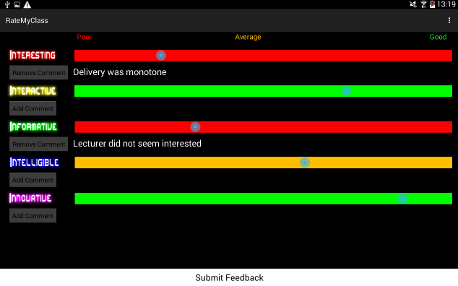

Figure 10: Layout of multiple SeekBars

After discussions with potential end users, a decision was made to deploy these in a vertical layout (*see Figure 10, above*). These discussions generated two other improvements to the UI:

* instead of being a red-green split, the entire SeekBar would change colour depending on the value selected (i.e. 0-33 is red, 34-66 is amber, 67-100 is green)
  + this was preferred as it allowed feedbacks to be categorised into three ‘levels’ – Poor, Average and Good – which further decreased the cognitive load placed on users by utilising colours, which can be processed more quickly by the human brain, in order to provide meaning and context to the input data
* instead of having a basic Spinner function for comments, the Spinner would be hidden by default, with an ‘Add Comment’ button to activate it.
  + This served to de-clutter the interface, and in turn make it more clear to the user when comments have (and have not) been selected.

#### User Story 2.5: I want to be able to select which module and lecturer a class belongs to immediately upon starting the app

This user story was the first item which was to be on a separate screen from the main feedback form – initially, the app was to show a screen which allowed the user to select which module and lecturer the class belonged to, and whether it was a lab or lecture. Once these had been selected, then the main feedback functionality would be initiated.

In collaboration with end user (as always), it was decided that this screen would be very simple (in order not to hinder the feedback process), using Spinners once again to allow selection of the 3 values and prevent any invalid data being input (*see Figure 11, below*).

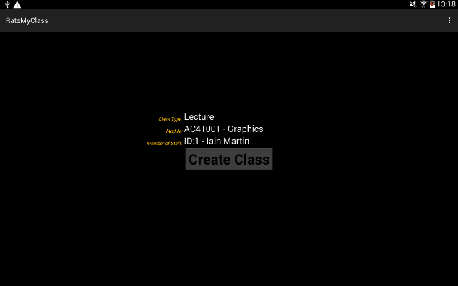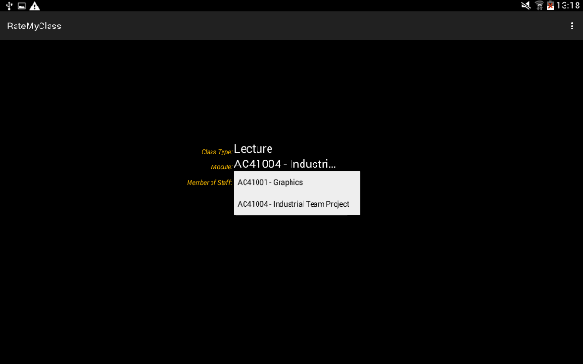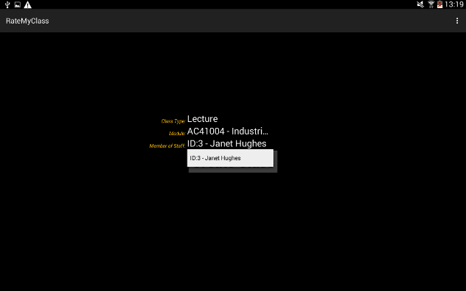

Figure 11: (Prototype) Class creation screen showing the 3 spinners

### Testing

As mentioned in the Evaluation of Sprint 1, this sprint was to include unit testing for the app. Accordingly, unit tests were written and run for both the main feedback activity and the class creation activity, testing the various UI features. As of the beginning of this sprint, development was to be test-driven, writing unit tests first and then writing code in order to pass these (*see example unit test, below*).

*public void testUI() throws Exception{*

*Spinner classType = (Spinner)activity.findViewById(R.id.typeSpinner);*

*assertEquals((String)classType.getItemAtPosition(0), "Lecture");*

*assertEquals((String)classType.getItemAtPosition(1), "Lab");*

*Spinner module = (Spinner)activity.findViewById(R.id.moduleSpinner);*

*assertNotNull(module);*

*Spinner staff = (Spinner)activity.findViewById(R.id.staffSpinner);*

*assertNotNull(staff);*

*Button btn = (Button)activity.findViewById(R.id.createBtn);*

*assertNotNull(btn);*

*}*

The tests all passed successfully. Of course, acceptance testing was also carried out for the 2 user stories developed in this sprint (*see below*).

**User Story 1.3**

1. *verify that I can select a value (‘score’) in the range 0-100 to represent how interactive the class was, where 0 is bad and 100 is good*
2. *verify that I can select a comment giving reasons for how interactive the class was*
3. *verify that I do not have to give a comment*
4. *verify that only one ‘score’ and one comment can be given for how interesting the class was*
5. *verify that there is conformation of successful submission*

**User Story 2.5**

1. *choose AC31007 from list of all modules and confirm that only Janet Hughes or Mark Zarb can be selected as staff member*
2. *choose AC51003 from list of all modules and confirm that only Craig Ramsay or Janet Hughes can be selected as staff member*
3. *confirm that only valid modules can be selected*
4. *receive confirmation message of successful creation of a class*

These all passed successfully.

### Evaluation/Retrospective

Looking back on Sprint 2, there were definitely improvements made in a few areas, most notably unit testing was introduced and implemented in a satisfactory manner (although code coverage of the unit tests produced could have, and probably should have, been greater). In terms of recording user interactions, discussions and feedback, much improvement is still needed – there was no real increase in the amount of captured, recorded interactions. The next sprint will have to focus on improving this.

Some feedback was received from staff, and will be implemented in the next sprint:

* Module code, module name and lecturer name to be displayed on main feedback screen (in ActionBar)
* SeekBars in main feedback screen to be set at midpoint by default

## Sprint 3

### Design/Implementation

#### User Stories 1.2, 1.4, 1.5: I want to be able to give feedback on how interactive/intelligible/innovative the class was (and why)

Developing these user stories involved, as mentioned regarding User Story 1.3 (*see section ‘Sprint 2’*), simply repeating the technique used to implement User Story 1.1. As mentioned in the last Evaluation/Retrospective, a focus was made in this sprint on increasing and prioritising user interactions – the majority of the work done in this sprint involved enhancing the app’s interface in response to user feedback. Some items of feedback addressed in this sprint included:

* Class Creation Screen
  + Make font colour uniform across all items on screen
  + Revised ordering of selectable items (Module -> Type of Class -> Lecturer)
* Feedback Screen
  + Change seekbar thumb colour to black to make it more visible against coloured background
  + Change seekbar default thumb position to the middle
  + Make colouring of the titles of the 5 ‘I’s uniform in order to reduce cognitive load and avoid confusion
* Make font style uniform throughout the app
* Add gradient effect to all buttons/seekbars in the app in order to improve aesthetics
* Add menu option to exit (and also to create a new class if in the Feedback Screen)

Some example code implementing some of these features can be seen below:

**Set SeekBar to midpoint:**

*mSeekBar.setProgress(45);*

**Gradient effect for SeekBar:**

*<layer-list* *xmlns:android="http://schemas.android.com/apk/res/android" >*

*<item android:id="@android:id/background">*

*<shape>*

*<!--<solid android:color="#FF0000" />-->*

*<gradient*

*android:startColor="#FF0000"*

*android:endColor="#ff640000"*

*android:angle="270"*

*></gradient>*

*<corners android:radius="7dp" />*

*</shape>*

*</item>*

*<item android:id="@android:id/progress">*

*<clip>*

*<shape>*

*<!--<solid android:color="#00FF00" />-->*

*<!--<solid android:color="#FF0000" />-->*

*<gradient*

*android:startColor="#FF0000"*

*android:endColor="#ff640000"*

*android:angle="270"*

*></gradient>*

*<corners android:radius="7dp" />*

*</shape>*

*</clip>*

*</item>*

*</layer-list>*

**Menu options:**

*@Override*

*public boolean onOptionsItemSelected(MenuItem item) {*

*int id = item.getItemId();*

*//noinspection SimplifiableIfStatement*

*if (id == R.id.action_exit) {*

*new SendEmail().execute();*

*finish();*

*return true;*

*}*

*if (id == R.id.action_newclass){*

*new SendEmail().execute();*

*startActivity(new Intent(getApplicationContext(), CreateClassActivity.class));*

*finish();*

*return true;*

*}*

*return super.onOptionsItemSelected(item);*

*}*

After performing these user stories and refining the UI, development on the app was now at an end – the ‘final version’ can be seen in the screenshots below:

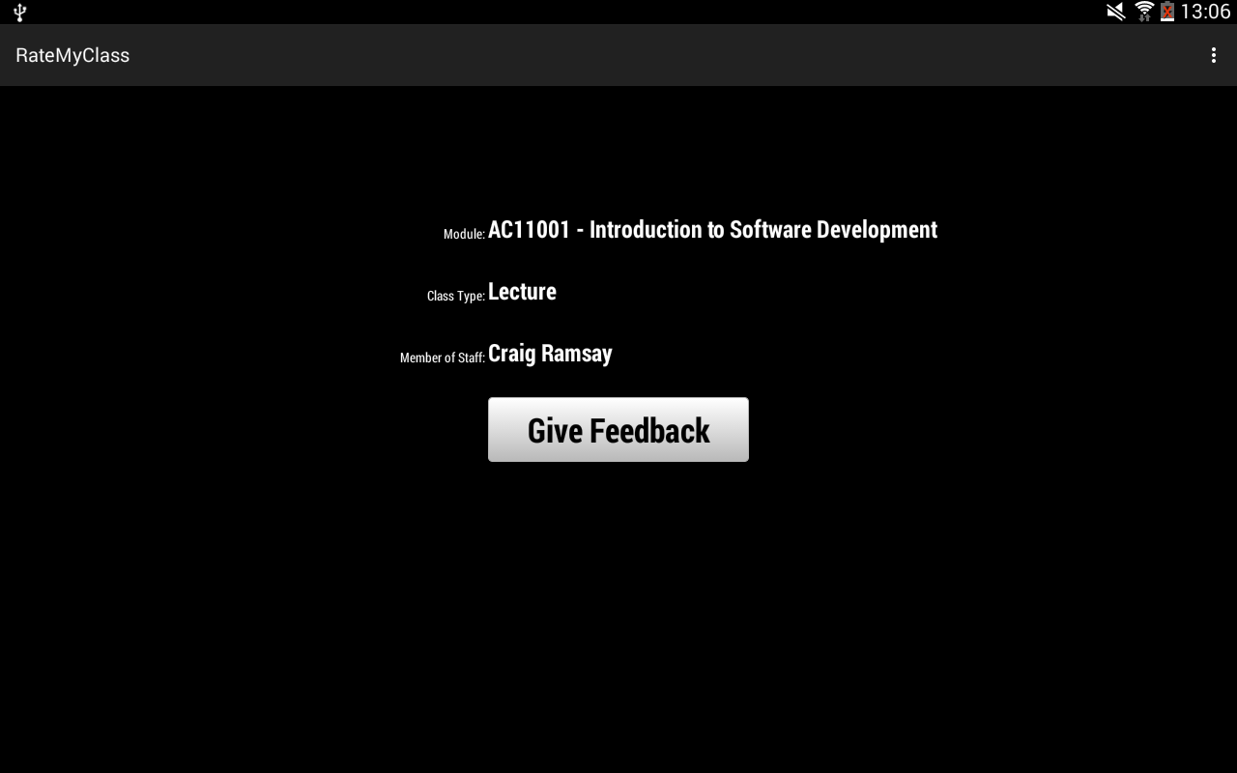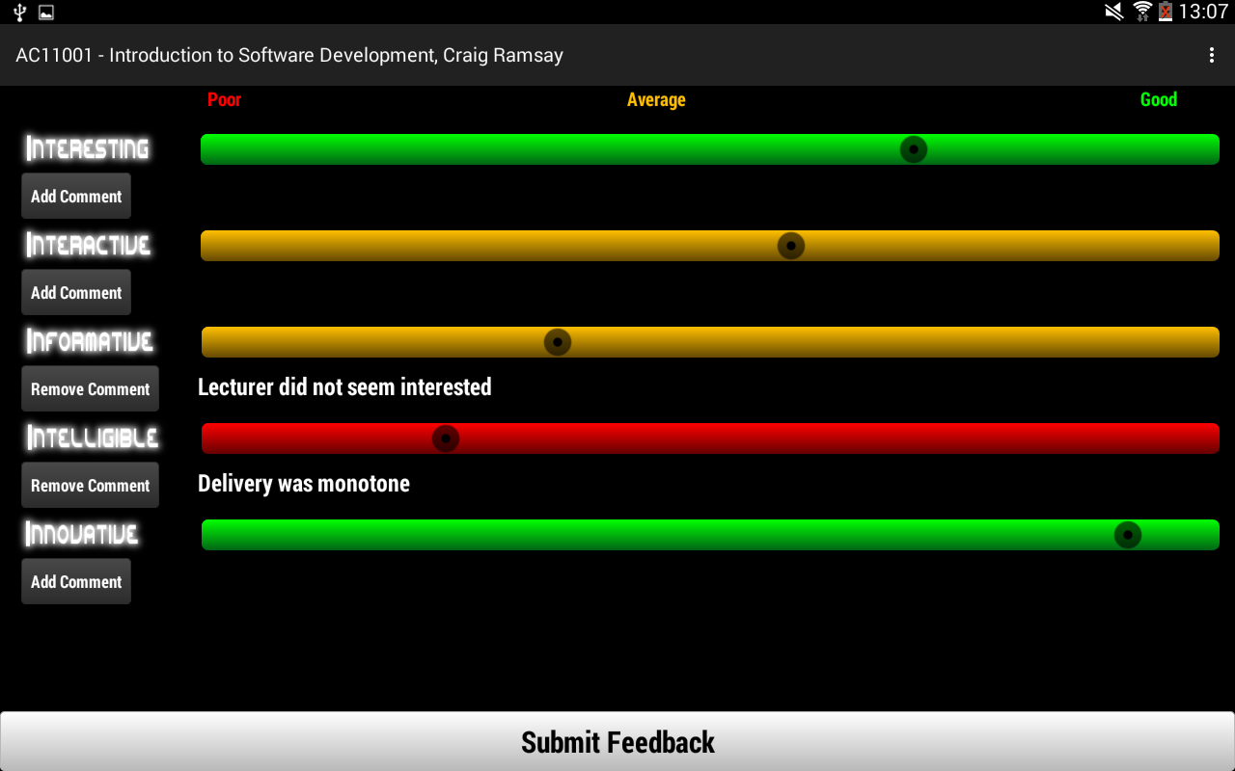

Figure 12: Screenshots of final app implementation

### Testing

Some more unit tests were introduced during this sprint, which tested the new UI items (*see below example unit test*).

*public void testUI() throws Exception{*

*SeekBar seekBar = (SeekBar)activity.findViewById(R.id.seekBar);*

*assertEquals(seekBar.getProgress(), 0);*

*seekBar = (SeekBar)activity.findViewById(R.id.seekBarInformative);*

*assertEquals(seekBar.getProgress(), 0);*

*seekBar = (SeekBar)activity.findViewById(R.id.seekBarInteractive);*

*assertEquals(seekBar.getProgress(), 0);*

*seekBar = (SeekBar)activity.findViewById(R.id.seekBarIntelligible);*

*assertEquals(seekBar.getProgress(), 0);*

*seekBar = (SeekBar)activity.findViewById(R.id.seekBarInnovative);*

*assertEquals(seekBar.getProgress(), 0);*

*Spinner comment = (Spinner)activity.findViewById(R.id.spinner);*

*assertTrue(comment.getVisibility() == View.INVISIBLE);*

*comment = (Spinner)activity.findViewById(R.id.spinnerInformative);*

*assertTrue(comment.getVisibility() == View.INVISIBLE);*

*comment = (Spinner)activity.findViewById(R.id.spinnerInteractive);*

*assertTrue(comment.getVisibility() == View.INVISIBLE);*

*comment = (Spinner)activity.findViewById(R.id.spinnerIntelligible);*

*assertTrue(comment.getVisibility() == View.INVISIBLE);*

*comment = (Spinner)activity.findViewById(R.id.spinnerInnovative);*

*assertTrue(comment.getVisibility() == View.INVISIBLE);*

*Button rmv = (Button)activity.findViewById(R.id.rmvBtnInteresting);*

*assertTrue(rmv.getVisibility() == View.GONE);*

*rmv = (Button)activity.findViewById(R.id.rmvBtnInteractive);*

*assertTrue(rmv.getVisibility() == View.GONE);*

*rmv = (Button)activity.findViewById(R.id.rmvBtnInformative);*

*assertTrue(rmv.getVisibility() == View.GONE);*

*rmv = (Button)activity.findViewById(R.id.rmvBtnIntelligible);*

*assertTrue(rmv.getVisibility() == View.GONE);*

*rmv = (Button)activity.findViewById(R.id.rmvBtnInnovative);*

*assertTrue(rmv.getVisibility() == View.GONE);*

*Button add = (Button)activity.findViewById(R.id.addBtnInteresting);*

*assertTrue(add.getVisibility() == View.VISIBLE);*

*add = (Button)activity.findViewById(R.id.addBtnIntelligible);*

*assertTrue(add.getVisibility() == View.VISIBLE);*

*add = (Button)activity.findViewById(R.id.addBtnInformative);*

*assertTrue(add.getVisibility() == View.VISIBLE);*

*add = (Button)activity.findViewById(R.id.addBtnInteractive);*

*assertTrue(add.getVisibility() == View.VISIBLE);*

*add = (Button)activity.findViewById(R.id.addBtnInnovative);*

*assertTrue(add.getVisibility() == View.VISIBLE);*

*final Button rmv2 = rmv;*

*final Button add2 = add;*

*final Spinner comment2 = comment;*

*activity.runOnUiThread(new Runnable() {*

*@Override*

*public void run() {*

*activity.addInnovativeComment(activity.getCurrentFocus());*

*assertTrue(rmv2.getVisibility() == View.VISIBLE);*

*assertTrue(comment2.getVisibility() == View.VISIBLE);*

*assertTrue(add2.getVisibility() == View.GONE);*

*}*

*});*

*}*

These all passed successfully. All of the acceptance tests for the 3 user stories developed in this sprint (*see below*) also passed successfully.

**User Story 1.2**

1. *verify that I can select a value (‘score’) in the range 0-100 to represent how informative the class was, where 0 is bad and 100 is good*
2. *verify that I can select a comment giving reasons for how informative the class was*
3. *verify that I do not have to give a comment*
4. *verify that only one ‘score’ and one comment can be given for how informative the class was*
5. *verify that there is conformation of successful submission*

**User Story 1.4**

1. *verify that I can select a value (‘score’) in the range 0-100 to represent how intelligible the class was, where 0 is bad and 100 is good*
2. *verify that I can select a comment giving reasons for how intelligible the class was*
3. *verify that I do not have to give a comment*
4. *verify that only one ‘score’ and one comment can be given for how intelligible the class was*
5. *verify that there is conformation of successful submission*

**User Story 1.5**

1. *verify that I can select a value (‘score’) in the range 0-100 to represent how innovative the class was, where 0 is bad and 100 is good*
2. *verify that I can select a comment giving reasons for how innovative the class was*
3. *verify that I do not have to give a comment*
4. *verify that only one ‘score’ and one comment can be given for how innovative the class was*
5. *verify that there is conformation of successful submission*

### Evaluation/Retrospective

In terms of the goals from the last retrospective, staff and student feedback was recorded to a more satisfactory level during Sprint 3. It was clear that user interactions as in general were more frequent and attempts were made to gather feedback from more sources (although not with a great deal of success – in the next sprint this could be rectified).

## Sprint 4

### Design/Implementation

#### User Story 2.3: I want to be able to view the feedback(s) for individual classes

#### User Story 3.1: I want to be able to view the feedback for all classes handled by a particular lecturer

#### User Story 3.2: I want to be able to view the feedback for all classes taken by a particular year group

In order to develop the above user stories which concern specific items of functionality for the RateMyClass website, the basic website structure and design had to be produced first.

After consultation with potential end users (**INSERT EVIDENCE)**, a simple structure was decided upon for the website, with slight variation depending on the user’s level of access (*see Figures 13, 14 and 15, below*).

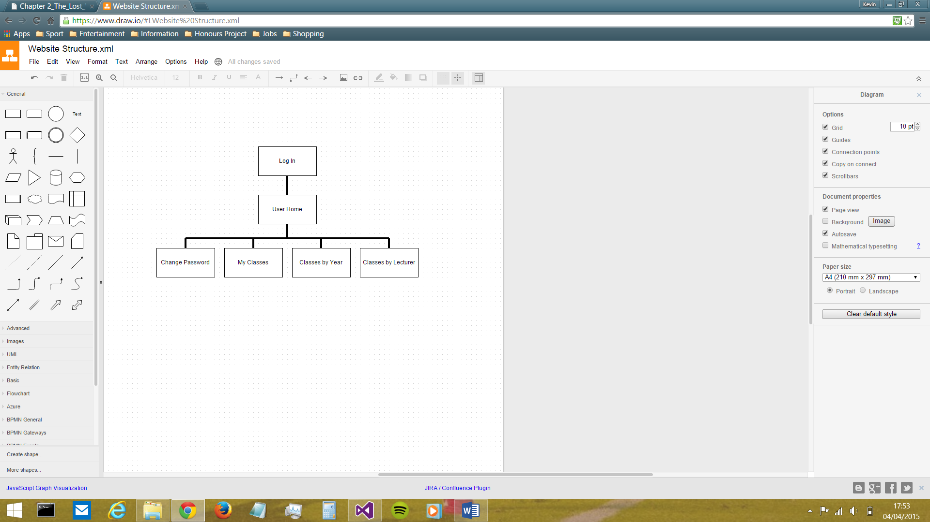

Figure 13: Website structure when logged in as a Dean

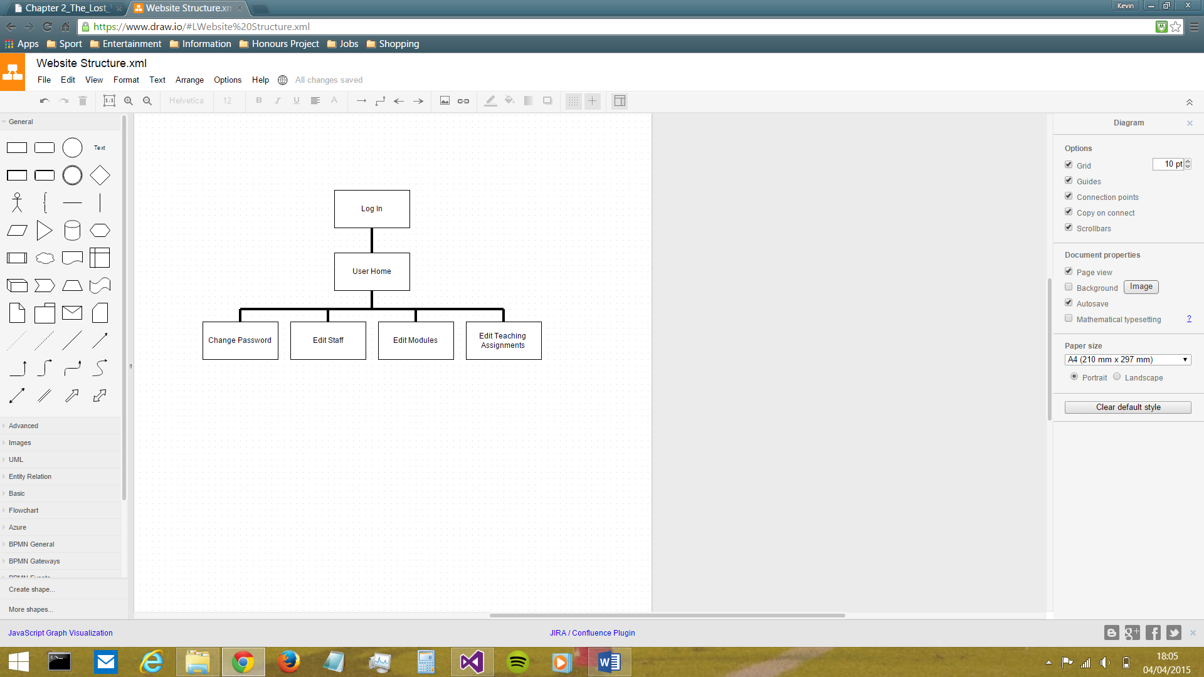

Figure 14: Website structure when logged in as an Admin

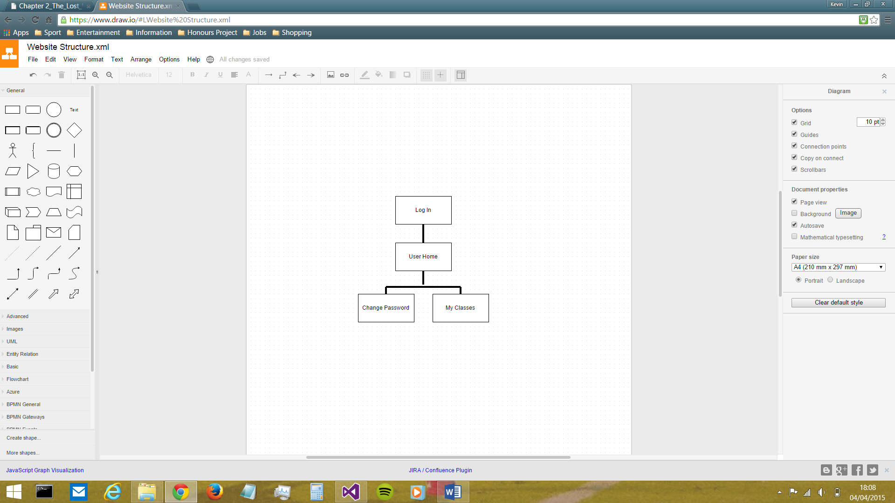

Figure 15: Website structure when logged in as a Lecturer

The login system was designed such that staff members would log in using their email and password which are stored in the RateMyClass database. These can be changed at any time by ‘admin’ members of staff, while each user also has the option to change their own password at any time as they so desire.

The differing levels of access were based upon the three staff types set out in the RateMyClass database: namely Lecturers, Deans and Admins. Lecturers have can only view their own feedback for classes they have conducted, whereas the Dean can view feedback for every class delivered in the School of Computing, reflecting the reality that the Dean alone is responsible for reviewing other staff members’ performance. The Dean can also view the feedback for each year, in order to ascertain which, if any, programmes of study need looked at. Admin staff have an entirely different role from the other two – instead of using the website as a means of viewing feedback, they are responsible for the maintenance of the database through the medium of the website. They can perform CRUD operations on the three database tables which are out of the app user’s sphere of control, i.e. the staff, the modules and the teaching assignments.

In terms of the UI design, bearing in mind that the app and the website were intended to be viewed as a single system (i.e. ‘RateMyClass’) there was an almost unanimous agreement amongst potential end users that there should be strong coherence and consistency between the interfaces of both, in order to make the usage of both seamless and easy and facilitate transfer of knowledge (Satzinger & Olfman, 1998). Therefore, the minimalist greyscale theme from the app was brought forward to the website also (*see Figures 16-25*, *below*). Keeping the colour scheme greyscale has the benefit of ensuring users with Colour Vision Deficiency will have no problems reading the text (National Disability Autority (of Ireland), n.d.).

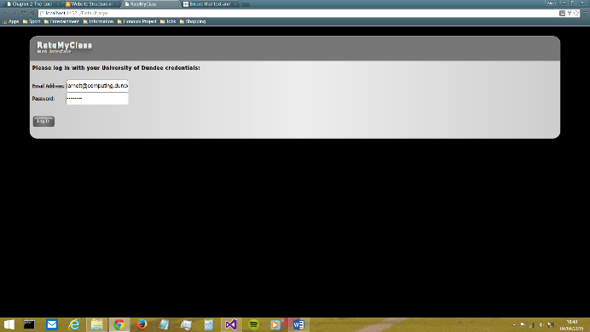

Figure 16: the 'Log In' screen

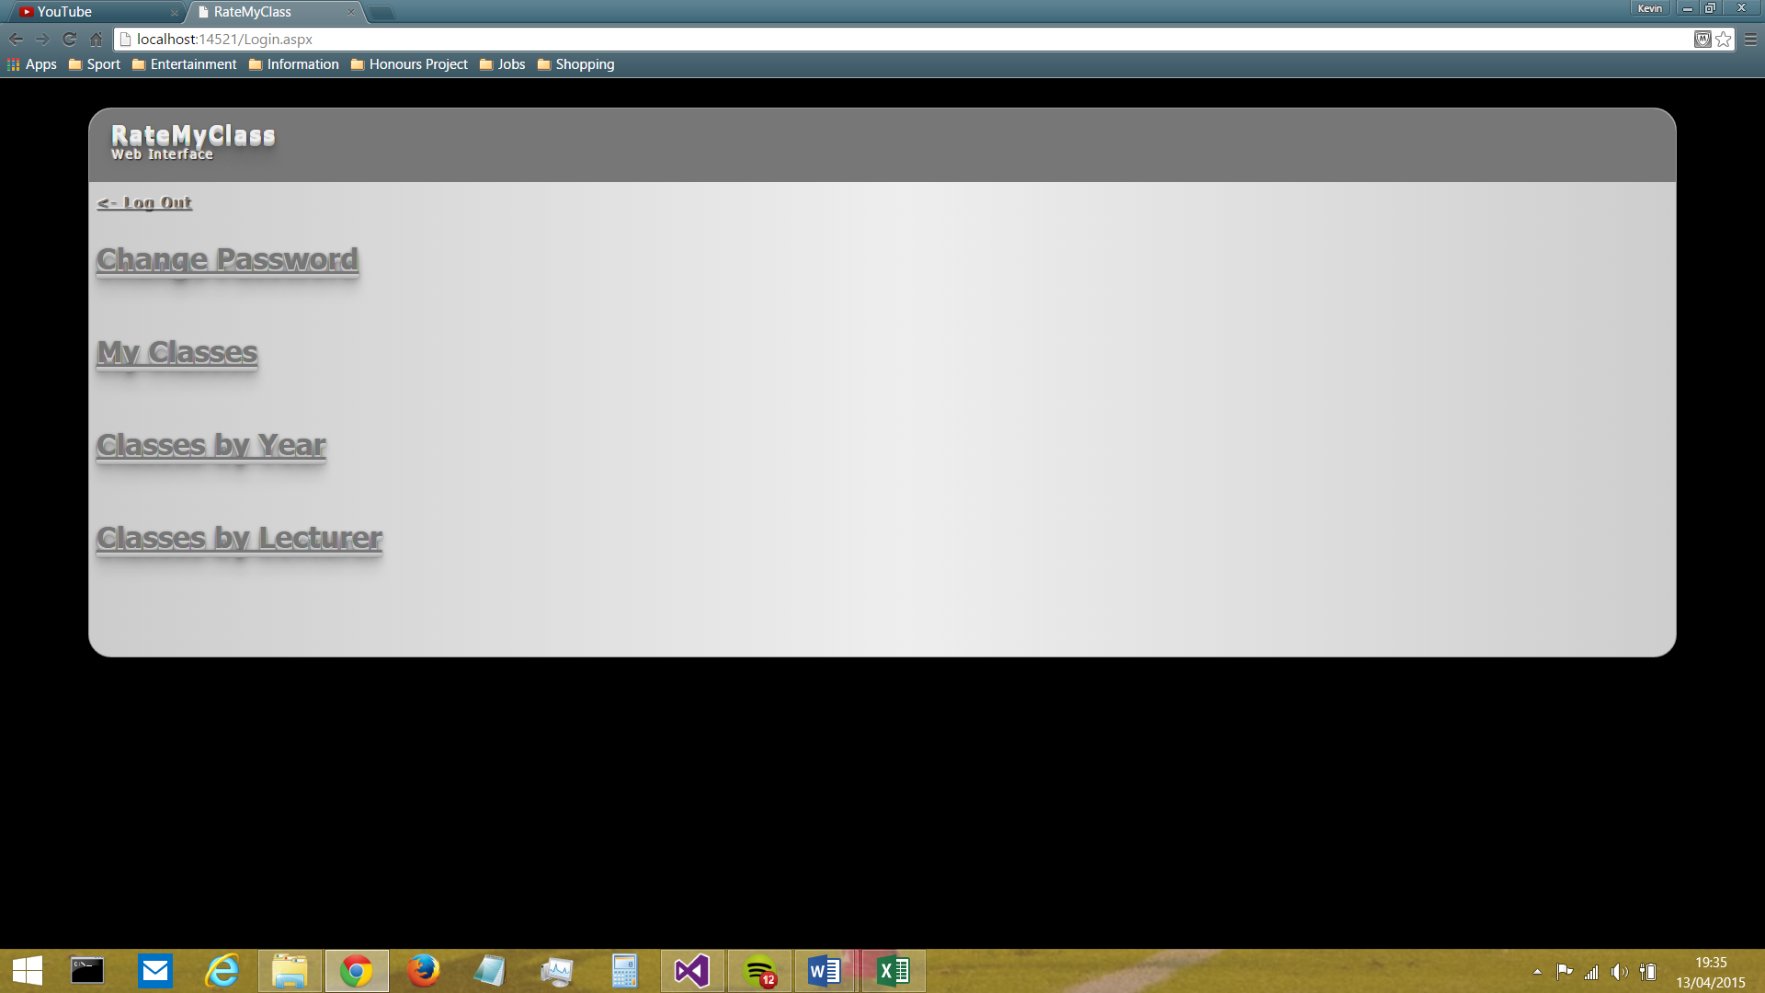

Figure 17: the 'User Home' screen

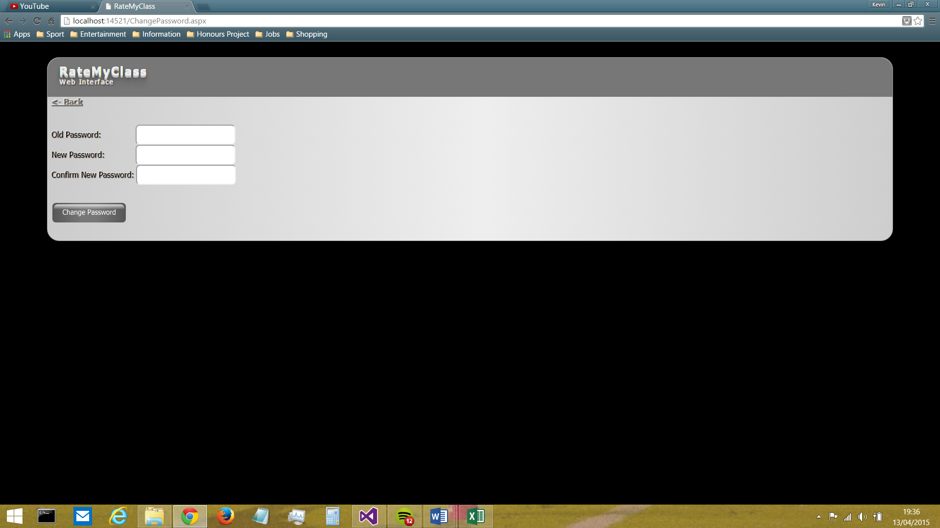

Figure 18: the 'Change Password' screen

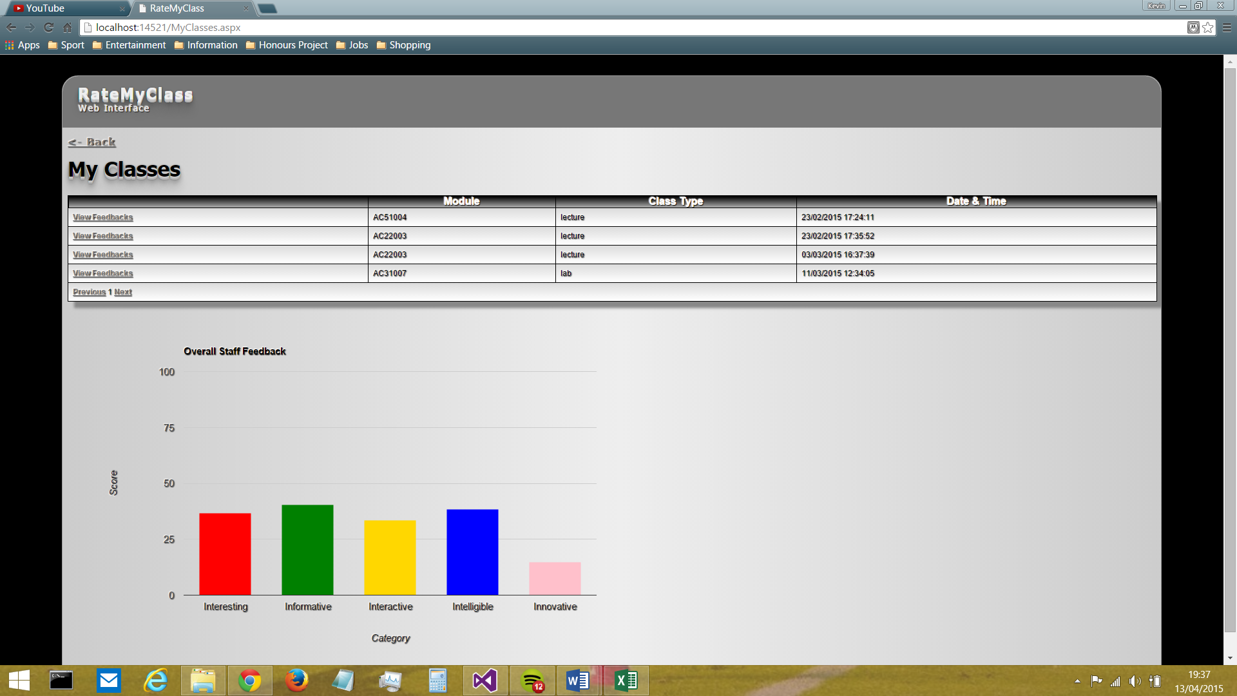

Figure 19: the 'My Classes' screen

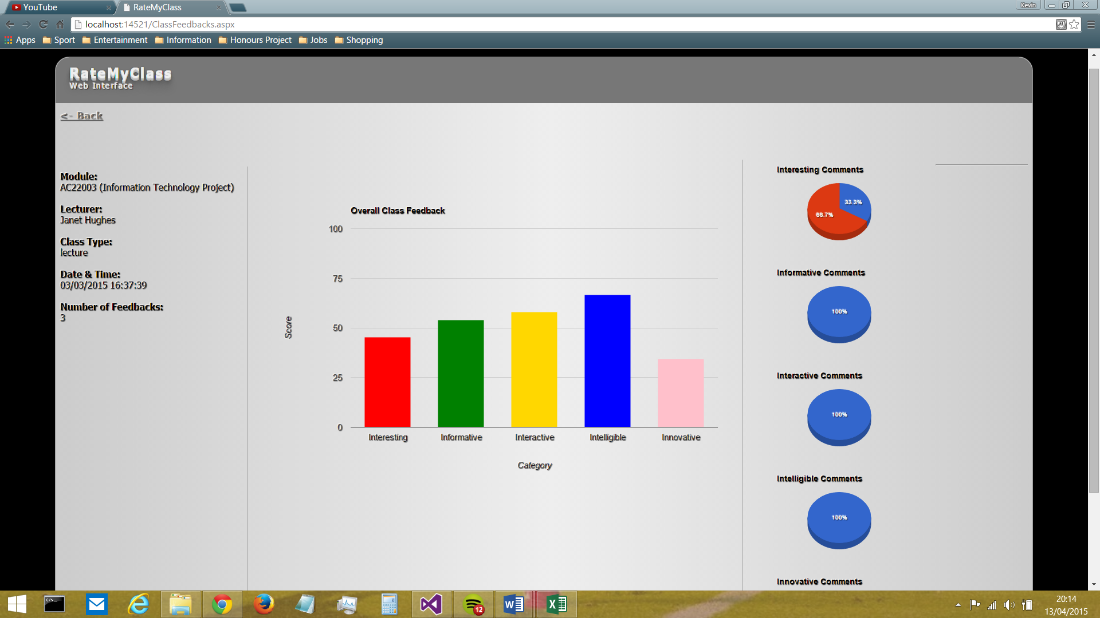

Figure 20: the 'Individual Class Feedback' screen

Figure 20 (above) shows the screen which displays the feedback information for a single class. During the design of this screen, staff indicated that, rather than showing the details of every individual item of feedback, it would be beneficial to portray the average feedback ‘score’ for the class. This was then taken forward, and a decision was made to display the average rating, along with the distribution of comments, for each of the 5 ‘I’s. In terms of the portrayal of these values, there was a choice to be made:

* Display ratings and comments in a linear fashion (e.g. in paragraphs or table(s))
  + Rejected as it was found that this method did not allow for an instant initial impression of the general nature of the data
* Use a form of visualisation to represent to the data
  + This was deemed the best option as these could utilise ‘pre-attentive attributes’ like difference in shape (e.g. varying heights of columns in column chart) to represent the differences in data visually, reducing the time and effort the human mind has to take in order to interpret the data (Few, 2004)

Taking this forward into the implementation, the Google Charts API was utilised in order to generate both a column chart to display the average ratings and 5 pie charts to display the distribution of comments across the 5 ‘I’s. This API was chosen as it was simple and easy to use, with a very good level of support available due to its popularity.

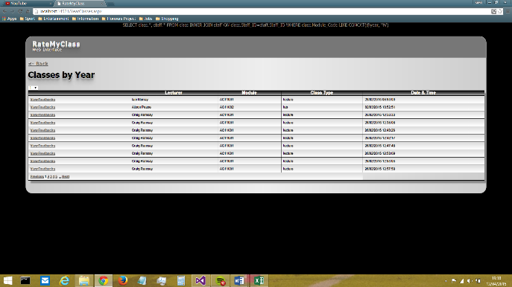

Figure 21: the 'Classes by Year' screen

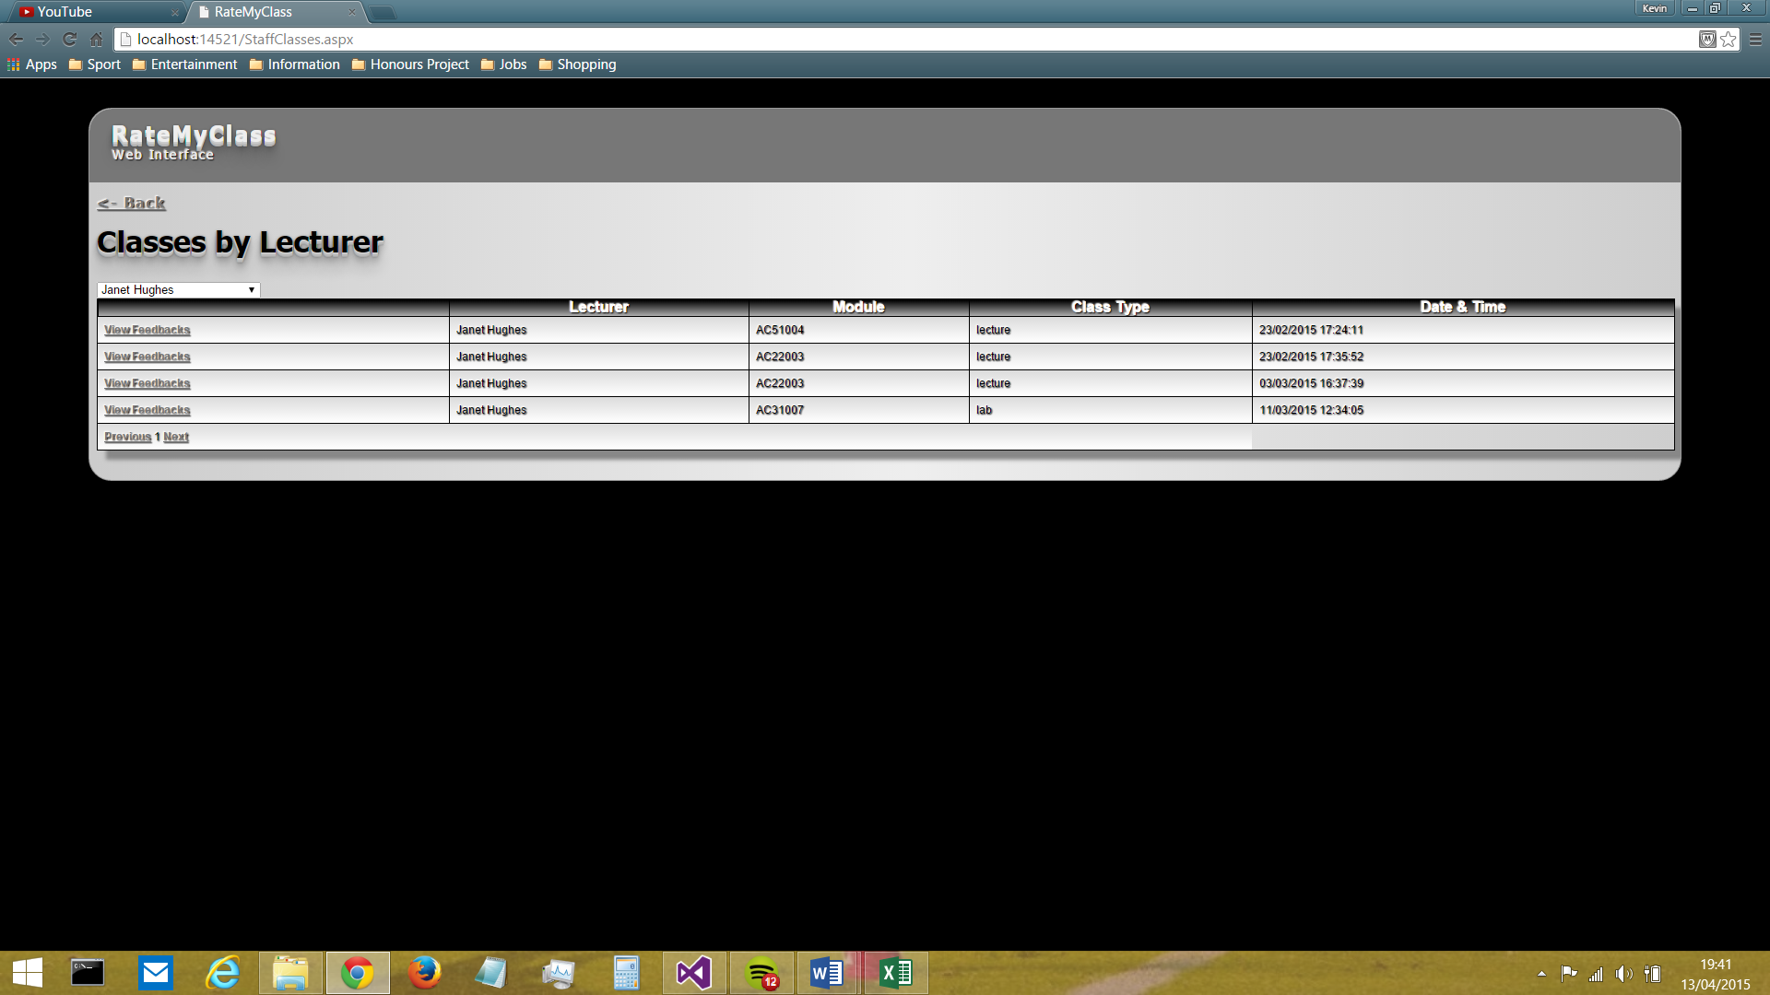

Figure 22: the 'Classes by Lecturer' screen

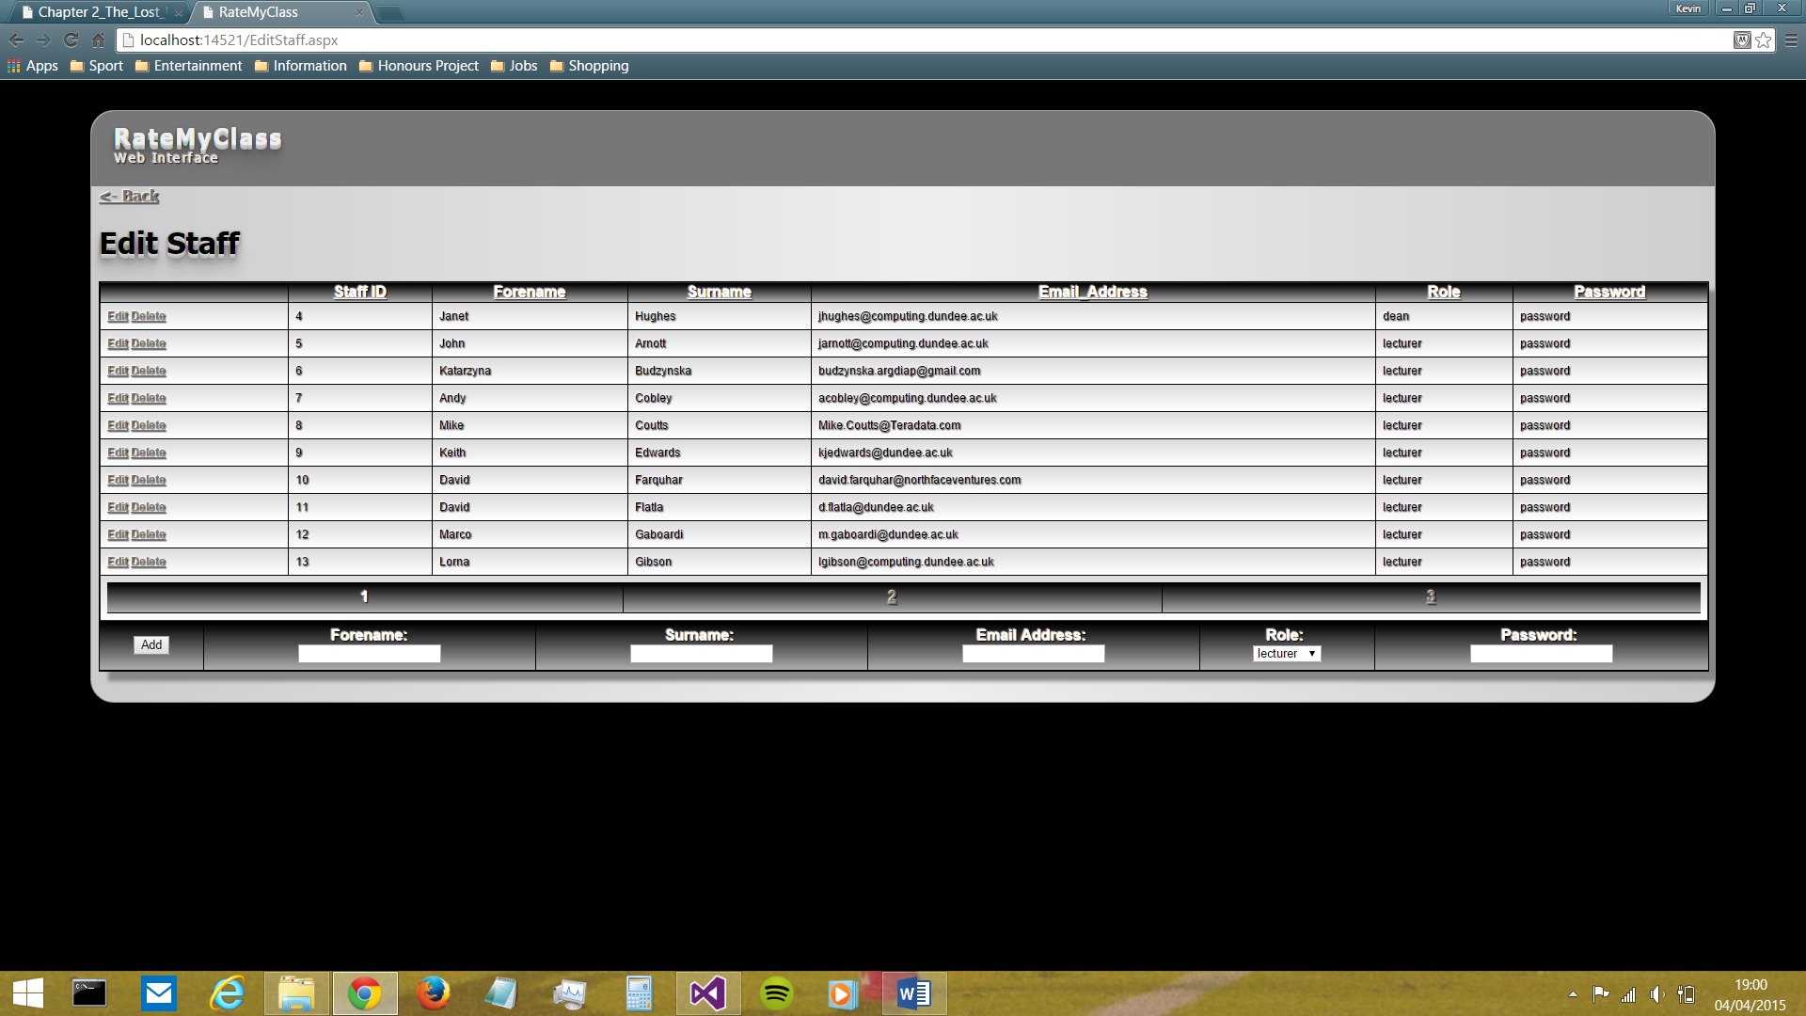

Figure 23: the 'Edit Staff' screen

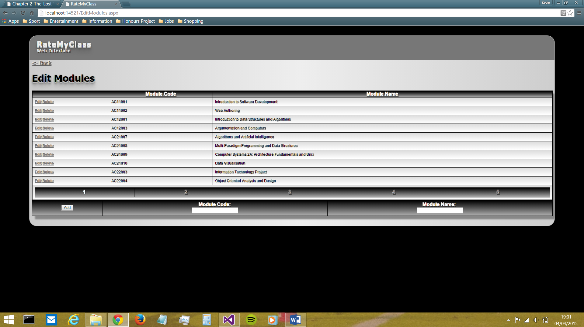

Figure 24: the 'Edit Modules' screen

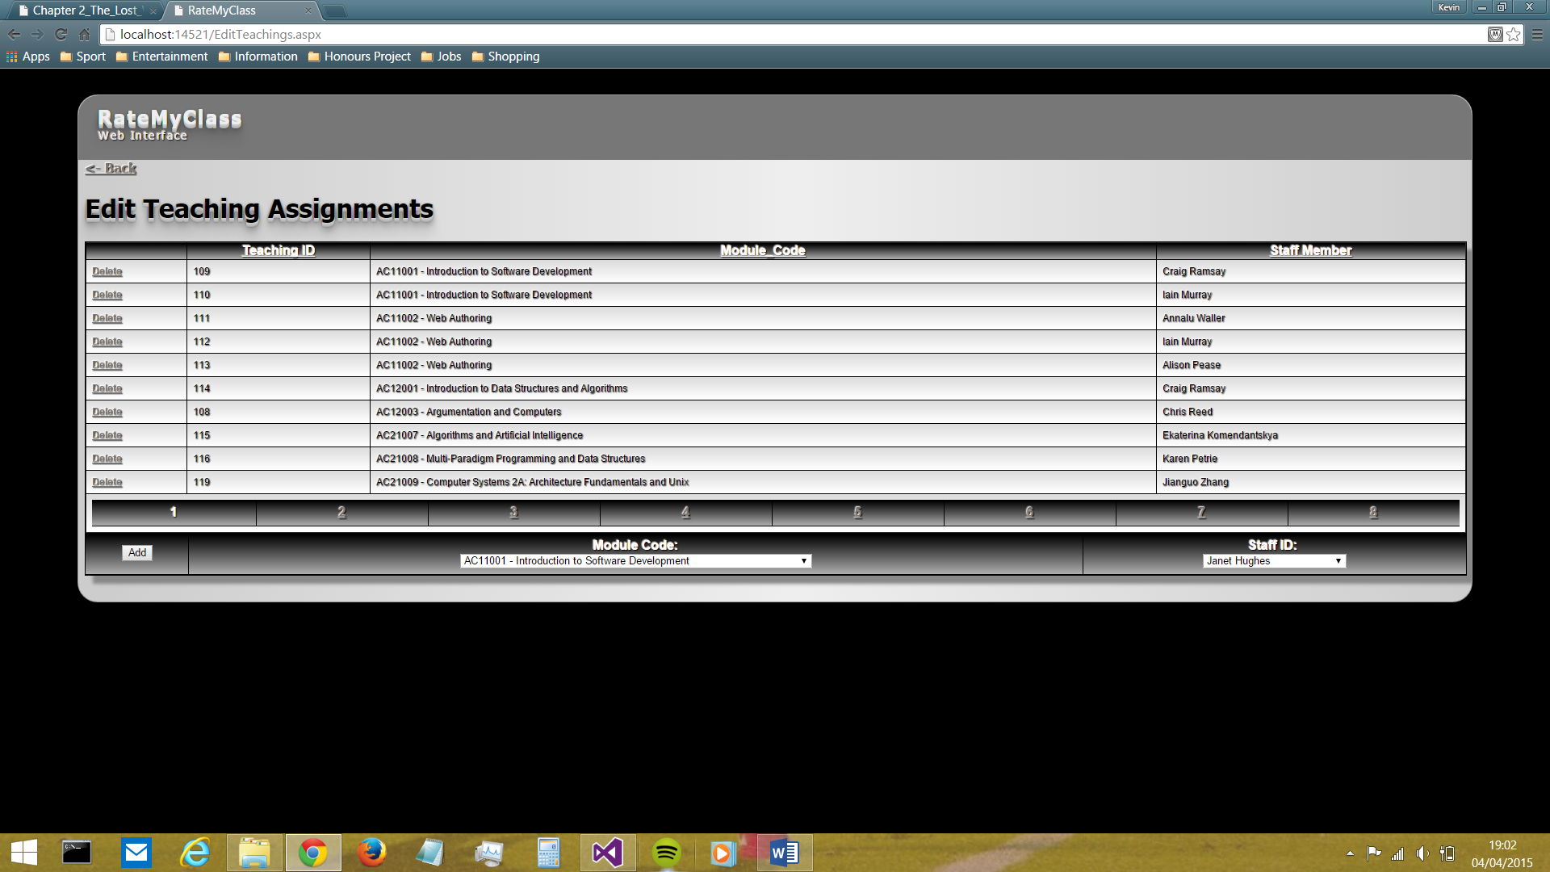

Figure 25: the 'Edit Teaching Assignments' screen

The three screens shown above (*Figures 23, 24 and 25* – *see Appendix B for higher-resolution versions of these*) highlight the ‘edit’ facilities available to admin staff. The main problem involved in the design of these screens was how to include all of the CRUD functionality in one place, in way that did not require a large cognitive load to be place on the user. After much research, it was decided that the GridView C# class would be used, as it provides the means to display data from a data source (in this case, the RateMyClass database) in a simple, easy-to-read table whilst also allowing for automatic generation of edit and delete buttons adjacent to each record. This was a very useful way to bring ‘read’, ‘update’ and ‘delete’ functionality together into one place. The only thing left to provide was therefore the ‘create’ functionality, and this was included below each GridView in a simple input form. Feedback from staff regarding these screens was very positive, particularly regarding the simplicity of the design.

Some minor negatives were also identified in the initial screen designs: firstly, the links on the ‘user home’ page were deemed to be too small (*see Figure 26, below*)

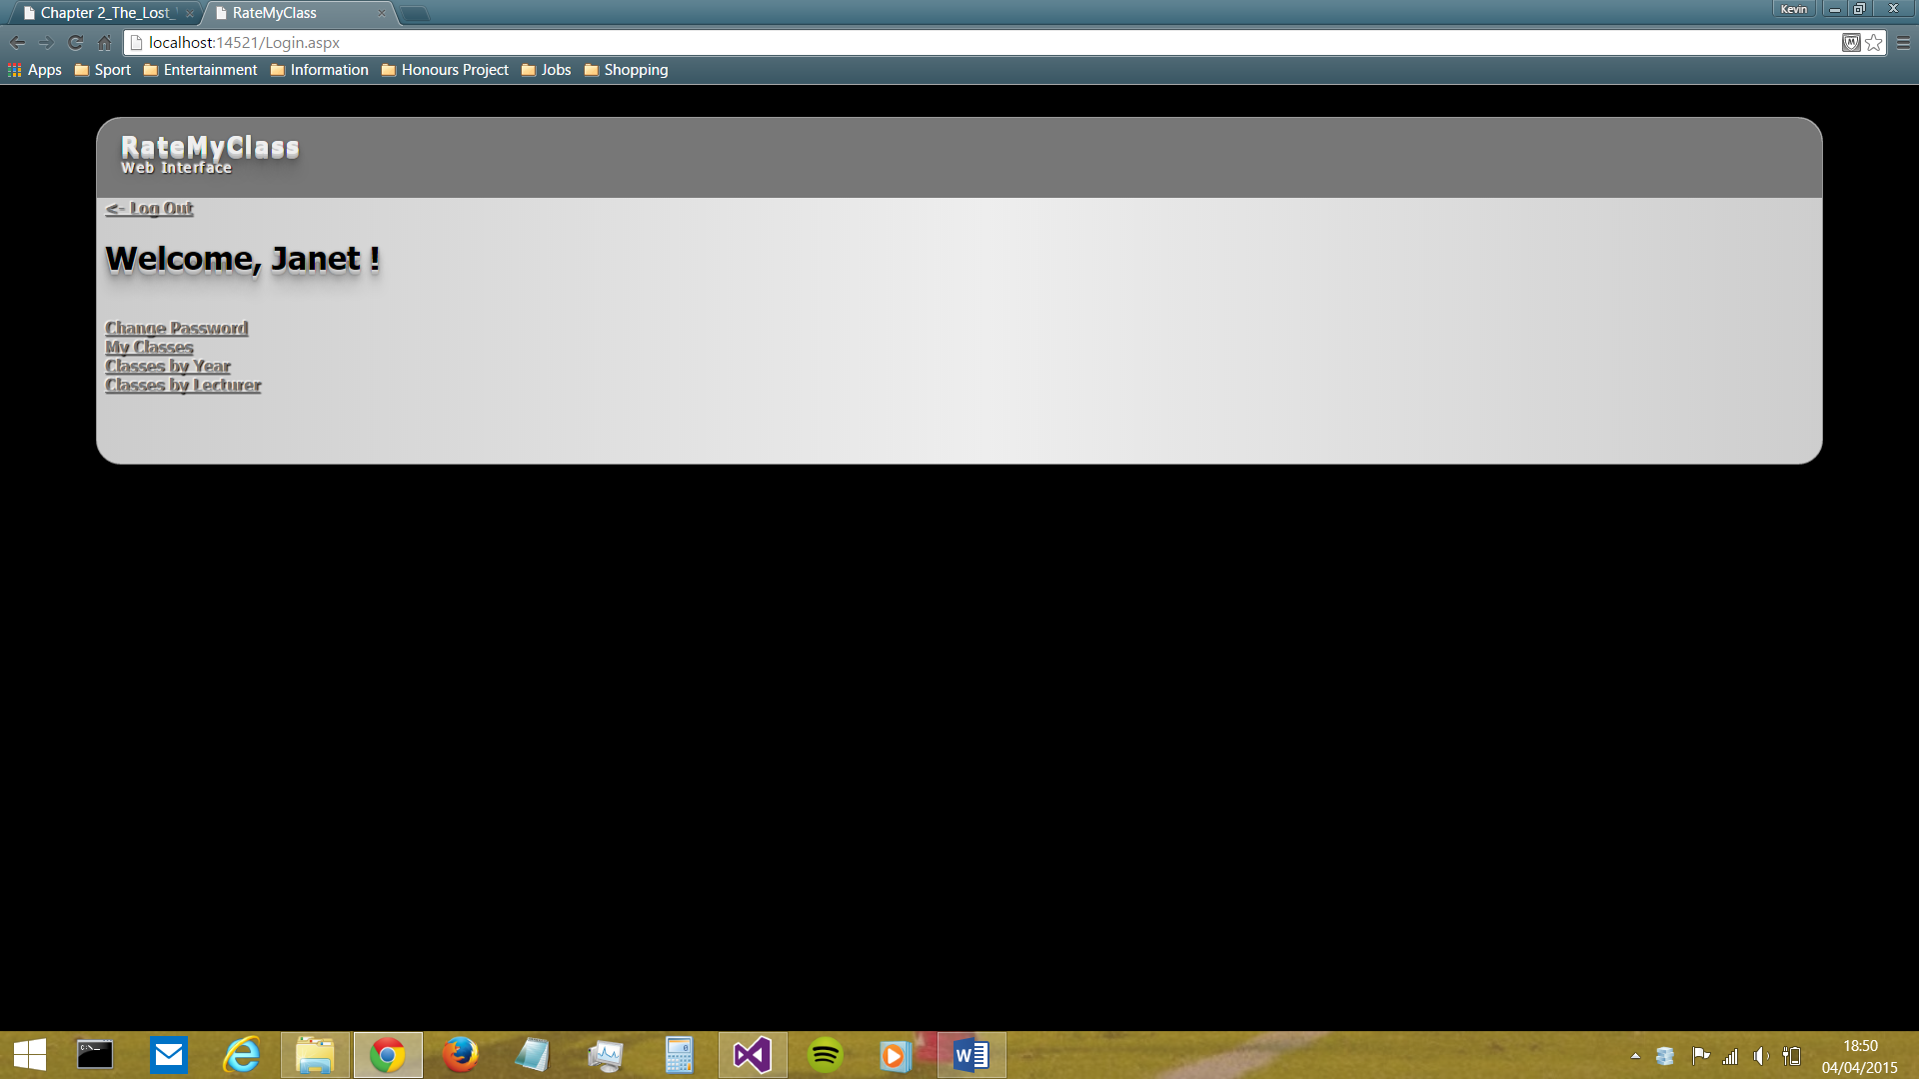



Figure 26: Changes made to User Home screen

In this way, the main functionality available to the user upon logging in was made much more clear and visible (resulting in less time wasted on visual search of the screen).

Additionally, it was brought to light that users felt the arrangement of the columns in the ‘My Classes’, ‘Classes by Year’ and ‘Classes by Lecturer’ screens were not the most efficient (**INSERT EVIDENCE)**(*see Figure 27, below*).

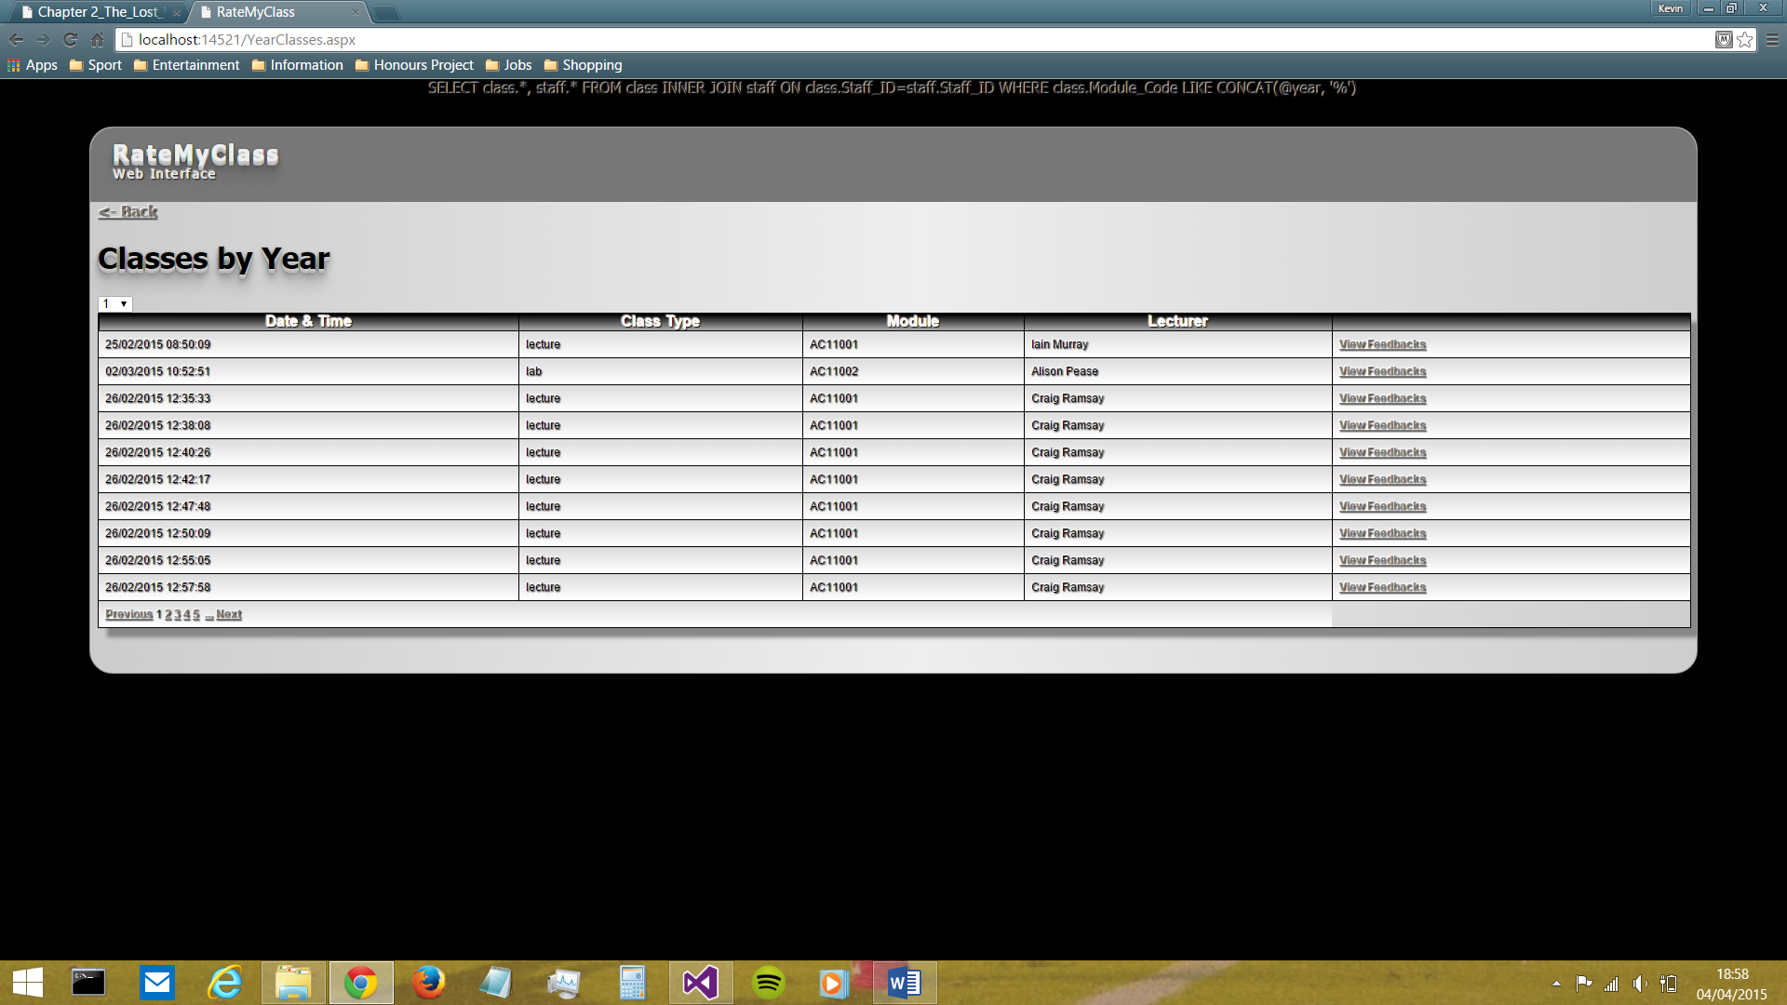

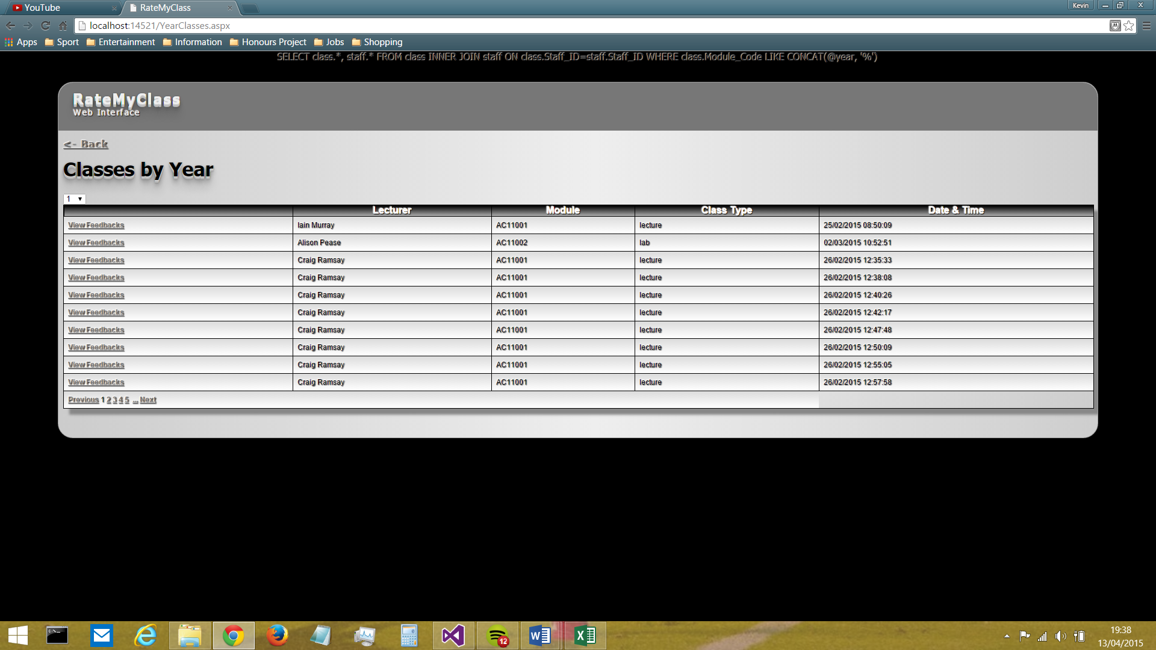

Figure 27: Changes made to columns in My Classes, Classes by Year and Classes by Lecturer screens

Therefore, the columns were re-arranged so that ‘View Feedbacks’ was leftmost, and thus in the initial vicinity of the cursor, meaning less time needed to navigate through pages. Lecturer and Module were also said by users to be more ‘important’ than Class Type and Date/Time, and so the former were moved left of the latter, closer to the user’s initial gaze.

Finally, certain items on the Class Feedbacks screen were said to be ‘too small’ (titles of pie charts) or ‘not clear enough’ (class information items) by a majority of users (*see Figures 28 and 29, below)*.

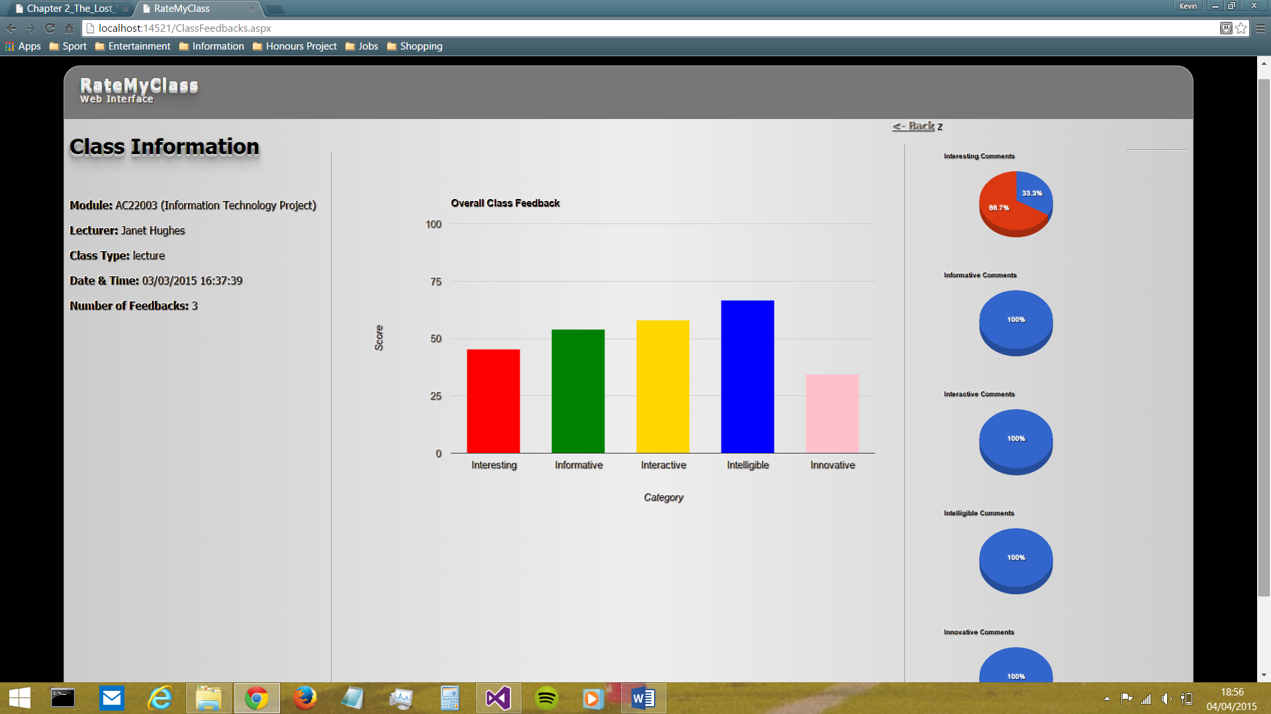



Figure 28: Changes made to the information items on the Class Feedbacks screen

The above change was welcomed by users - the separation between title and value making the value itself more clear at first glance.





Figure 29: Changes made to the pie charts on the Class Feedbacks screen

The premise for the above change was simple: by making the font size larger, the text became more visible to users and therefore each pie chart became more easily identifiable.

### Testing

Since this sprint resulted in the completion of the development of RateMyClass (in its ‘version 1.0’ state), the final user testing took place during it. This consisted of the following methods:

Final interviews were conducted with a selection of students. A total of six students (unfortunately far less than intended) participated in these interviews, although one of them declined to complete the System Usability Scale questionnaire (due to time constraints). These participants were obtained through the use of personal contacts and via word of mouth.

* + They were asked to briefly use the Android app.
  + A researcher was present, in order to record how students were using it (in terms of 2 main variables – time taken to give feedback and no. of errors made).
  + They were then asked a series of pre-defined questions, and asked to complete a System Usability Scale (SUS) and demographics questionnaire (see attached documents).
  + They were also offered the opportunity to give any comments.

The quantitative results yielded were very positive (*see Figure 30 and Table 1, below*). Individual students were able to provide feedback in a very short space of time (an average of 15.3s), which would certainly be suitable for the intended usage of the app, where each student in a class would quickly give feedback upon exiting the room/theatre/lab. For example, in a class of 25 students, it would therefore take roughly 6 minutes in total for all feedback to be provided (and that figure is assuming the worst case scenario of only one tablet device being available and every single student in the class wanting to use it to give feedback), which is certainly an acceptable outcome.

Even more positive was that no errors were made by any of the students, which is testimony to the robustness of the app (a lot of which is due to the fact that user input is restricted to selection from pre-defined lists – the user cannot provide any ‘custom’ input which could cause errors).

Figure 30: Time Taken for an Individual to Provide Feedback

Table 1: Table of Quantitative Results yielded by User Testing

|  |  |  |
| --- | --- | --- |
|  | **Time Taken (s)** | **No. of Errors** |
|  | 13 | 0 |
|  | 9 | 0 |
|  | 23 | 0 |
|  | 19 | 0 |
|  | 13 | 0 |
|  | 15 | 0 |
| **AVERAGE:** | 15.3 | 0 |

In terms of the qualitative testing of the app, the System Usability Scale (S.U.S.) questionnaire (Brooke, 1996) also yielded positive results (*see Figure 31 and Table 3, below*). Across all of the questions, both on average and in every individual response, there was no score below the boundary of 3 (i.e. there were no outright negative responses). This had to be viewed as a very satisfactory set of results. These results also highlighted how well certain key targets, which were defined at the outset of the project, have been met (*see Table 2, below*)

Table 2: How targets were shown to be met by the S.U.S. questionnaire

|  |  |
| --- | --- |
| **Target** | **Level of Success** |
| Keep the app simple for users | Very high score of 4.4/5 indicating that users did not find product to complex |
| Ensure consistency throughout the app (e.g. in terms of font style, layout, design, colour, etc.) | Very high score of 4.4/5 indicating that users found the product to be consistent |
| Use an intuitive design to require as little learning as possible for those new to the app | Perfect score of 5 indicating that users think they could learn to use the product very quickly |

Figure 31: S.U.S. questionnaire results

Table 3: Table of S.U.S questionnaire results (both individual participants' and average scores)

|  |  |  |  |  |  |  |  |  |  |  |
| --- | --- | --- | --- | --- | --- | --- | --- | --- | --- | --- |
| **Participant** | **Q1** | **Q2** | **Q3** | **Q4** | **Q5** | **Q6** | **Q7** | **Q8** | **Q9** | **Q10** |
| P1 | 4 | 4 | 5 | 4 | 4 | 4 | 5 | 5 | 4 | 5 |
| P2 | 4 | 5 | 5 | 4 | 4 | 5 | 5 | 4 | 4 | 5 |
| P3 | 3 | 4 | 4 | 4 | 3 | 4 | 5 | 3 | 3 | 4 |
| P4 | 4 | 4 | 4 | 4 | 3 | 4 | 5 | 4 | 4 | 5 |
| P5 | 4 | 5 | 5 | 4 | 4 | 5 | 5 | 5 | 4 | 5 |
| **AVERAGE:** | 3.8 | 4.4 | 4.6 | 4 | 3.6 | 4.4 | 5 | 4.2 | 3.8 | 4.8 |

Unfortunately, the results obtained through these two methods of user testing do not carry as great a weight as originally intended, due to the low number of participants which took part.

### Evaluation/Retrospective

As mentioned in the retrospective for the previous sprint, this sprint needed to include feedback from a wider variety of sources. Unfortunately, despite further attempts to rectify this, various circumstances dictated that not as wide a variety feedback sources were utilised as would have been preferable.

Furthermore, as mentioned previously, the user testing would have carried much more weight had more participants been obtained. Next time, in order to rectify this issue, more efforts will be made to obtain participants (e.g. distributing emails and flyers which invite students to take part).

# Summary and Conclusions

In summary, when the developed software system and users’ positive reactions to it are taken into account, it must be said that this project has been a success. The system is now fully ready for real-world implementation in the School of Computing.

###### Future Work

In terms of the future, there is a clear direction that should be taken, that being modifying the app for use on individual smartphones and tablets, so each student can provide feedback on their own device, thus saving valuable time.

# Acknowledgements

Acknowledgements go to:

Janet Hughes, Dean of the School of Computing and supervisor of this project

The six student participants in user testing

# References

Brooke, J. (1996). SUS: a "quick and dirty" usability scale. *Usability Evaluation in Industry*, 4-7.

Dufresne, R. J., Gerace, W. J., Leonard, W. J., Mestre, J. P., & Wenk, L. (1996). Classtalk: A Classroom Communication System for Active Learning. *Journal of Computing in Higher Education*, 3-47.

Few, S. (2004, September 4). *Tapping the Power of Visual Perception.* Retrieved from Perceptual Edge: http://www.perceptualedge.com/articles/ie/visual_perception.pdf

Foth, M., Fitz-Walter, Z., Ti, J., Russell-Bennett, R., & Kuhn, K.-A. (2012). Please Take Out Your Phones: On the Spot Solicitation of Student Feedback in Class . *Proceedings of the 24th Australian Computer-Human Interaction Conference* (pp. 150-153). Melbourne: ACM.

Johnson, B. (2009, February 3). *Student Feedback Helps Teachers Grow*. Retrieved from eduTopia: http://www.edutopia.org/student-feedback-accountability-teachers

National Disability Autority (of Ireland). (n.d.). *Ensure that text and graphics are readable by users with limited vision or reading disorders*. Retrieved from The Centre for Excellence in Universal Design: http://universaldesign.ie/Technology-ICT/Digital-TV-equipment-and-services/guidelines-for-digital-tv-equipment-and-services/On-screen-interfaces/Ensure-that-text-and-graphics-are-readable-by-users-with-limited-vision-or-reading-disorders/

Satzinger, J. W., & Olfman, L. (1998). User interface consistency across end-user applications: the effects on mental models. *Journal of Management Information Systems - Special section: Managing virtual workplaces and teleworking with information technology*, 167-193.

Sharma, M. D., Khachan, J., Chan, B., & O'Byrne, J. (2005). An investigation of the effectiveness of electronic classroom communication systems in large lecture classes. *Australasian Journal of Educational Technology*, 137-154.

Theys, M. D., Lawless, K., & George, S. (2005). Tablet computers and the traditional lecture. *Frontiers in Education, 2005. FIE '05. Proceedings 35th Annual Conference* (pp. T2G-7). Indianapolis, IN: IEEE.

Zarraonandia, T., Aedo, I., Díaz, P., & Montero, A. (2013). An augmented lecture feedback system to support learner and teacher communication. *British Journal of Educational Technology*, 616-628.

# Appendices

## Appendix A – System Usability Scale questionnaire

|  |  |  |  |  |  |
| --- | --- | --- | --- | --- | --- |
|  | Strongly Disagree  1 | 2 | 3 | 4 | Strongly  Agree  5 |
| 1. I think that I would like to use this product frequently |  |  |  |  |  |
| 1. I found the product was not too complex |  |  |  |  |  |
| 1. I thought the product was easy to use |  |  |  |  |  |
| 1. I think that I would be able to use this product without the support of a technical person |  |  |  |  |  |
| 1. I found the various functions in the product were well integrated |  |  |  |  |  |
| 1. I though the product was consistent |  |  |  |  |  |
| 1. I imagine that most people would learn to use this product very quickly |  |  |  |  |  |
| 1. I didn’t find the product awkward to use |  |  |  |  |  |
| 1. I felt very confident using the product |  |  |  |  |  |
| 1. I could get going with this product without having to learn a lot of things |  |  |  |  |  |

### Appendix B – High-Resolution Screens of ‘Edit’ Web Pages

